Hindi Vidya Prachar Samiti’s
RAMNIRANJAN JHUNJHUNWALA COLLEGE OF ARTS ,SCIENCE AND COMMERCE
(EMPOWERED AUTONOMOUS)

Database & Warehousing



Name: Surajkumar Yadav
Roll no: 10302
Class: MSc. Data Science and Artificial Intelligence Part I


Ramniranjan Jhunjhunwala College
of Arts, Science and Commerce

Department of Data Science and Artificial Intelligence

CERTIFICATE

This is to certify Surajkumar Yadav of MSc. Data Science and Artificial Intelligence Roll No. 10302 has successfully completed the practical of Database & Warehousing during the Academic Year 2024-2025.
Date:

(Prof. Sujata) External Examiner
Prof-In-Charge

INDEX
Sr No. | Practical Name | Date
1 | RDBMS (SQL) | 12/7/24
2 | Performing MongoDB CRUD operations | 19/7/24
3 | Performing MongoDB aggregation operations | 19/7/24
4 | Performing Sorting in MongoDB | 26/7/24
5 | Performing MongoDB Comparison Operators | 26/7/24
6 | Performing MongoDB Logical Operators | 26/7/24
7 | Performing MongoDB $abs , $floor and $ceil operations | 2/8/24
8 | Performing MongoDB $log , $mod , $divide and $multiply operations | 2/8/24
9 | Performing MongoDB $pow , $sqrt , $subtract operations | 3/8/24
10 | Performing MongoDB $trunc, $round , $compare operations | 3/8/24
11 | Performing MongoDB $concat, $size , $rename operations | 3/8/24
12 | Implementation of Supervised Learning  - Decision Tree  - Logistic Regression  - KNN  - Linear Search – Euclidean Distance  - Naïve Bayes Classifier | 3/8/24
13 | Implementation of Unsupervised Learning  - Clustering  - Hierarchical Clustering  - Density Based Clustering  - Simple KMeans  - Apriori Algorithm | 3/8/24
Practical 1 : RDBMS
Create a table customer with attributes (CustomerID PK,C_Name,C_Address,C_Phone,Salary )
Insert min 10 rows in to the table
CREATE TABLE Customer (
customerID INT PRIMARYKEY,
customername VARCHAR (20),
customerAddress VARCHAR (20),
customerPhone INT,
Salary INT DEFAULT=20000 );

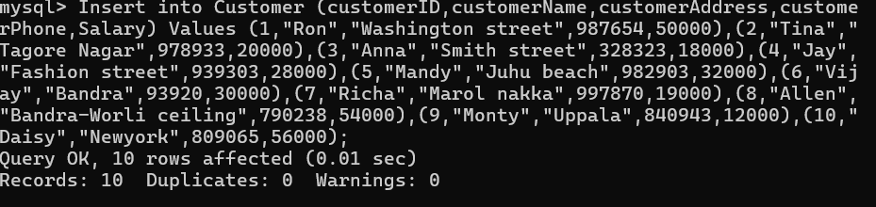
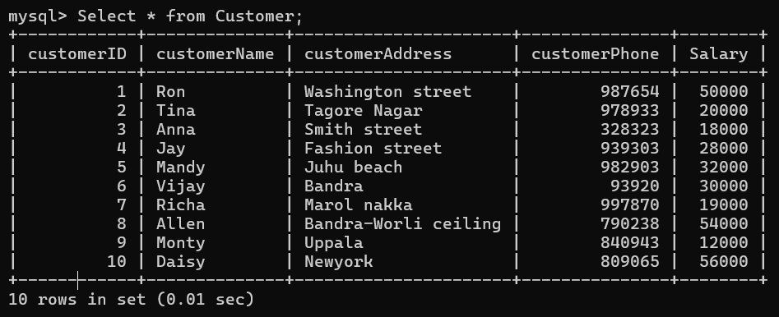
1. Display Customer details whose salary is greater than 20000 .
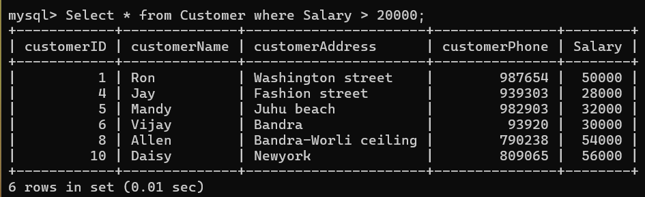
2. Display Customer details whose salary is 20k and 30k.
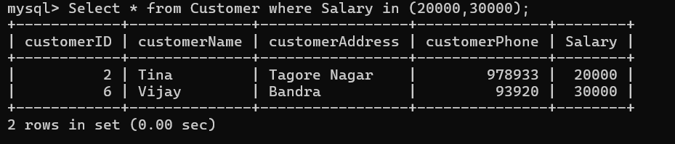

3. Display Customer details whose salary is 20k or 30k.
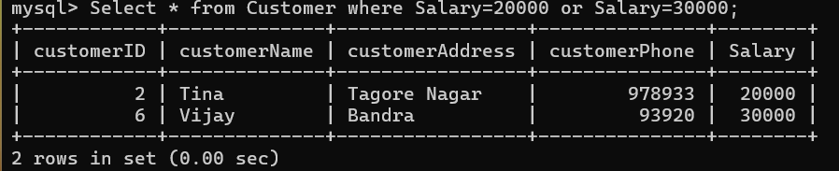
4. Display Customer whose salary is not less than 20,000.
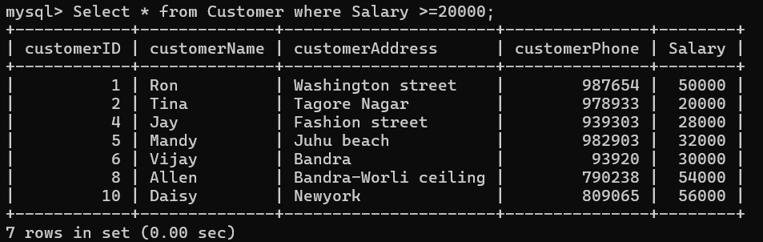
5. Update Customer table and add 2 new columns.
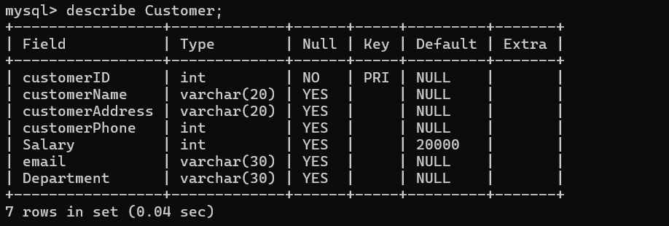
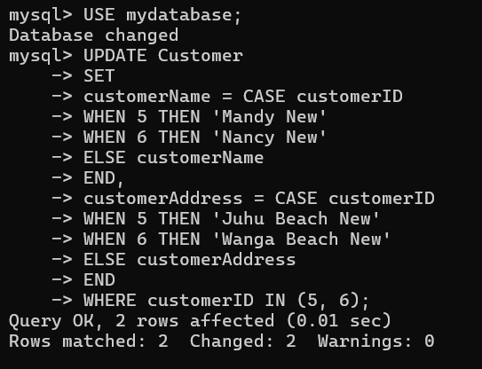
6. Update Customer table and add 2 rows.
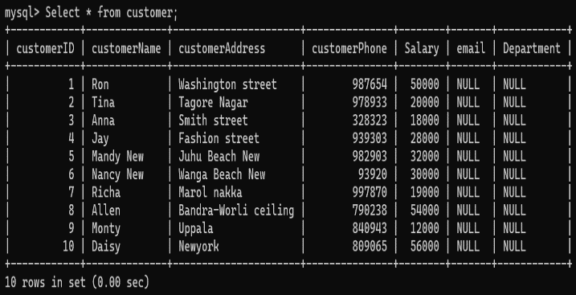

Practical 2 : Performing MongoDB CRUD operations
show dbs ;
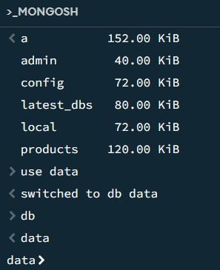
Creating a Database :

Create collection :
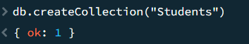
InsertOne:
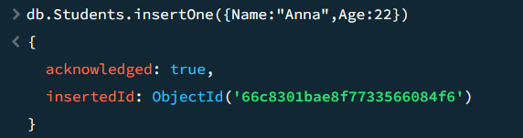
InsertMany:
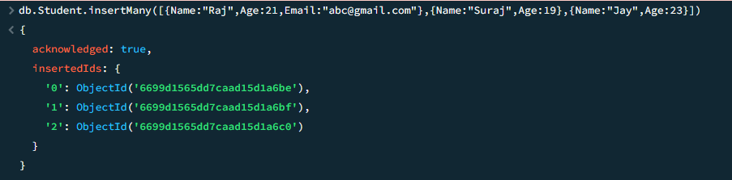

Find Clause:
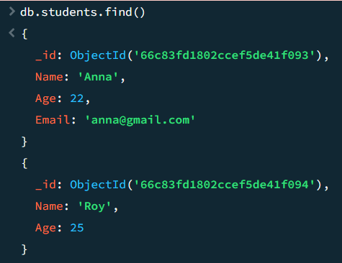
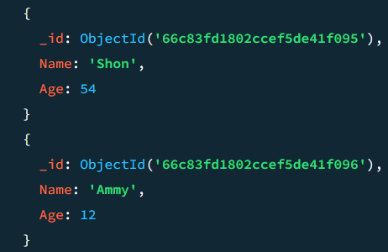
Find with filters:
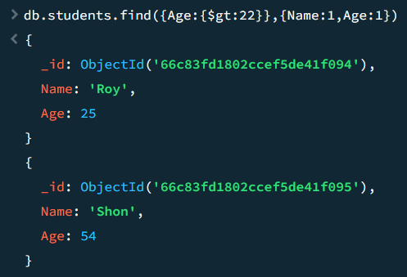
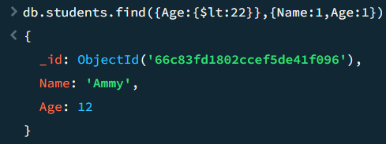
Find one :
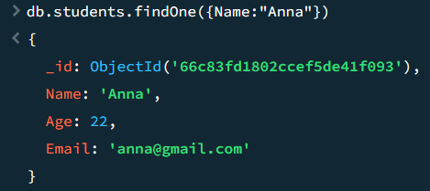

Update Clause :
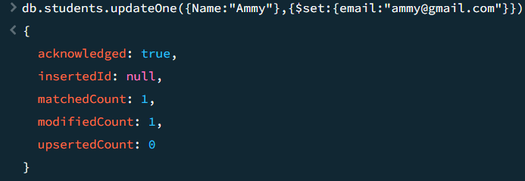
Insert Many
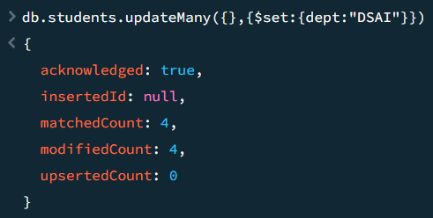
Delete one :
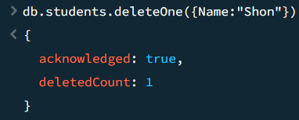
Delete many :
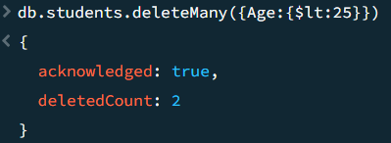
Drop Collection :
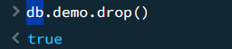
Drop Database :
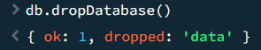

Practical 3 : Performing MongoDB aggregation operations
Perform MongoDB aggregation operation use an aggregation function to filter the sales by the Americanos, Calculate the some of quantity group of size and sort the results

Data :
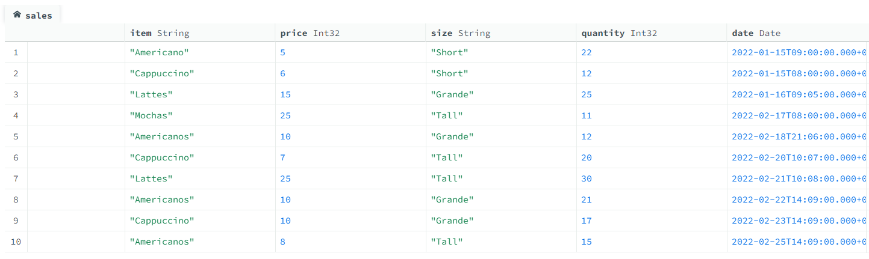
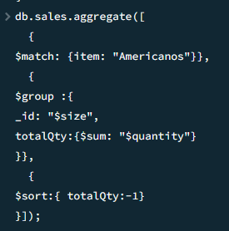
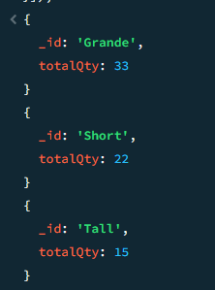

Practical 4 : Performing Sorting in MongoDB
Data : 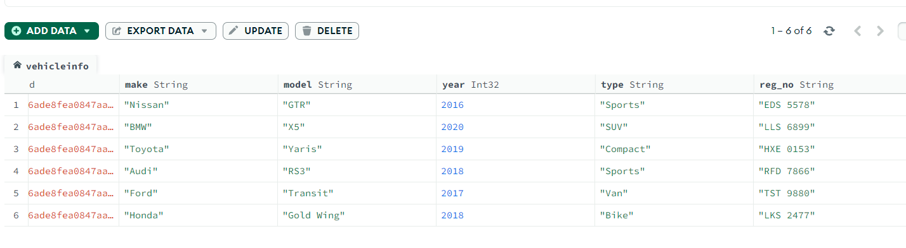
1. Sort the data by year
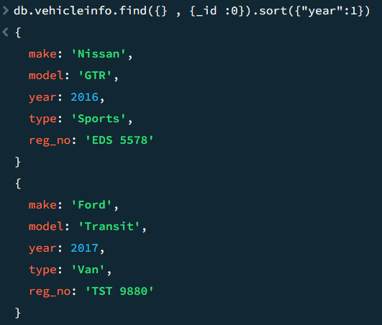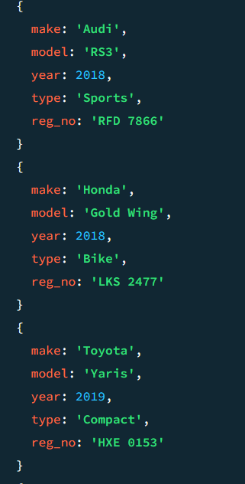
2. Sort the Data by brand name and display only “make”
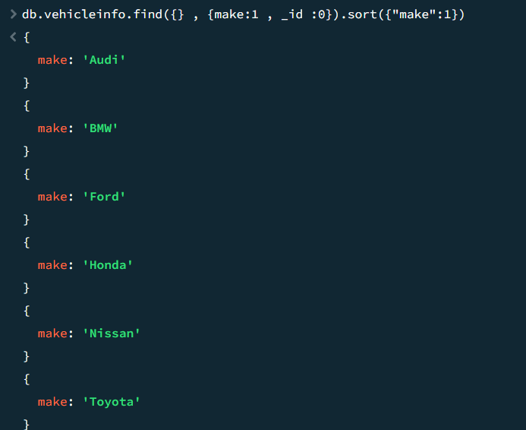

3. Sort the data by brand name in reverse order
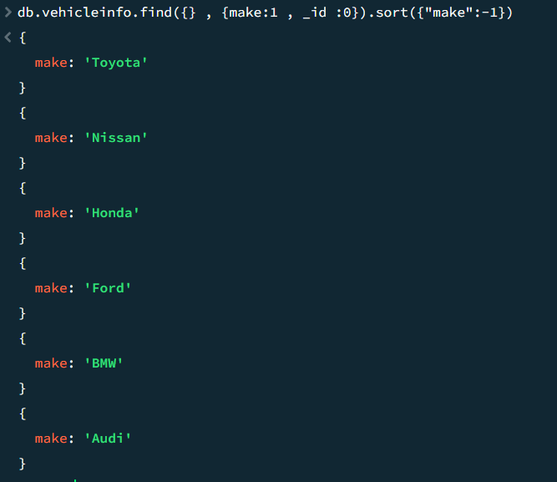
4. Sort the data by make and price
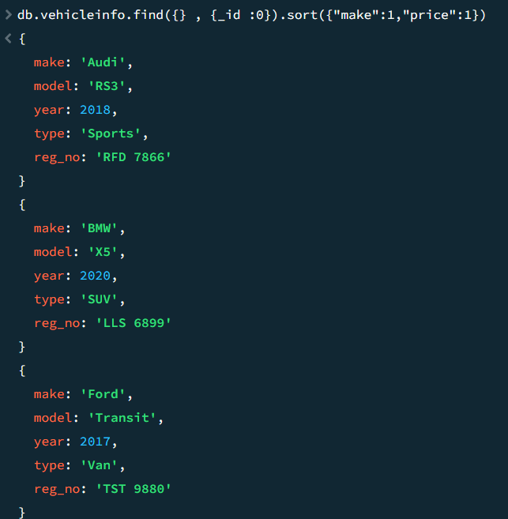

5. Sort the data by year and make , display only the first 2 data
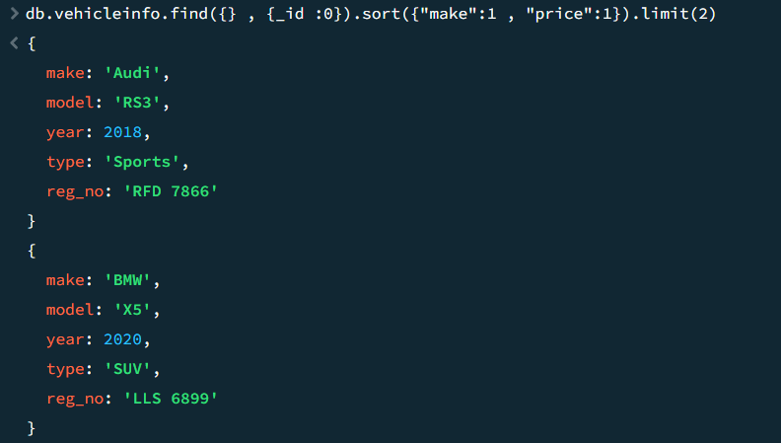

6. Sort the data by year skipping the first 4 values
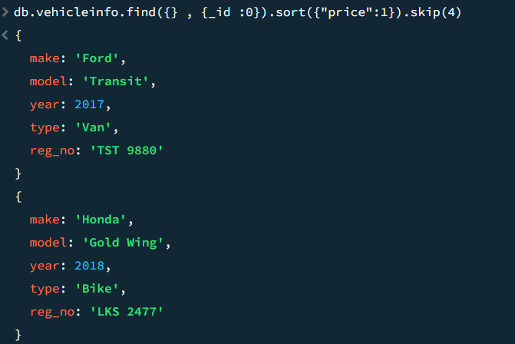

Practical 5 : Performing MongoDB Comparison Operators
Data :
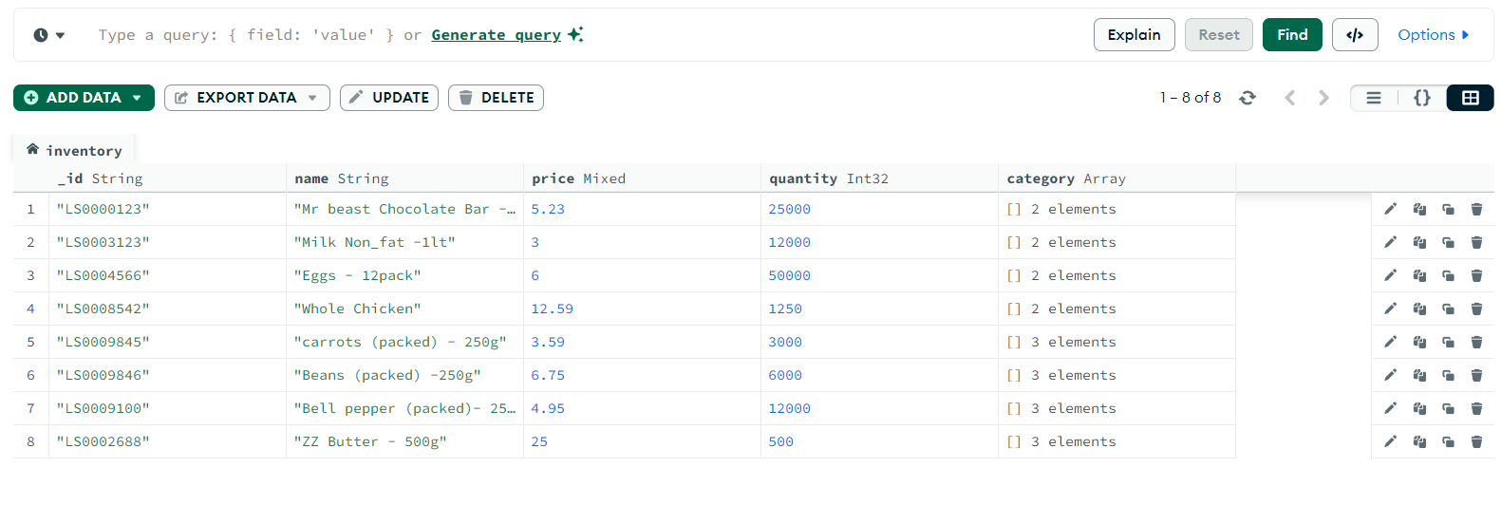
- $eq operator
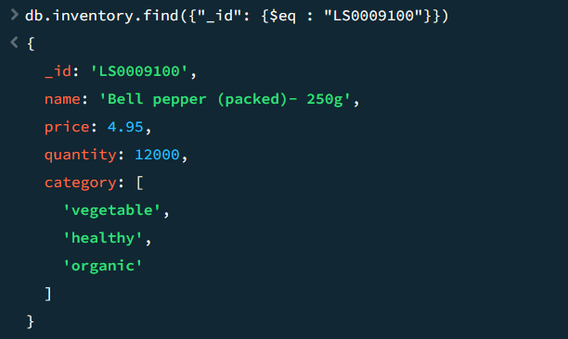

- $gt and $lt operator
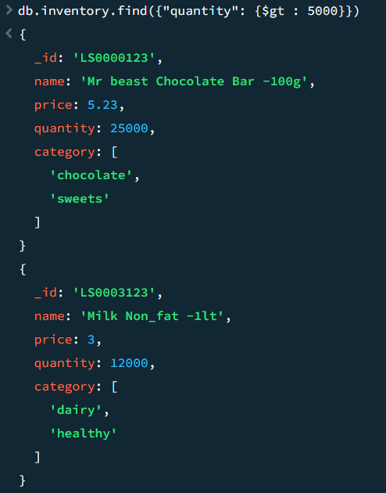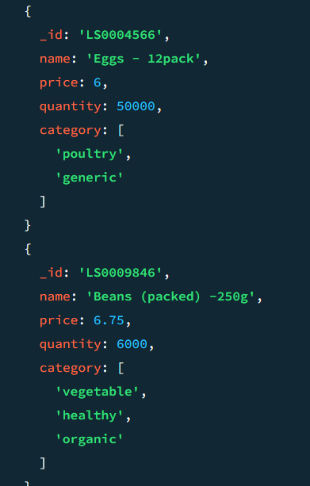
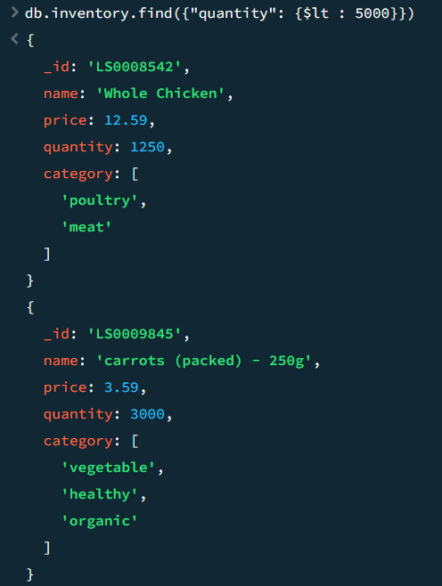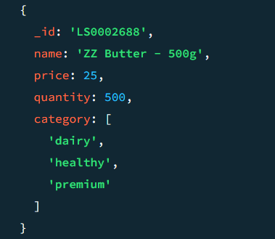
- $gte and $lte operator
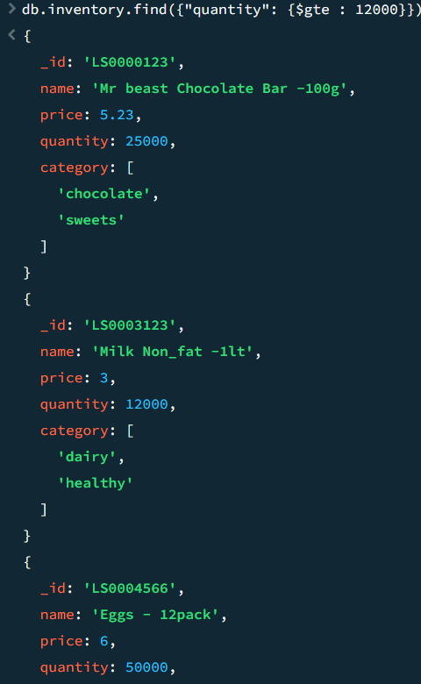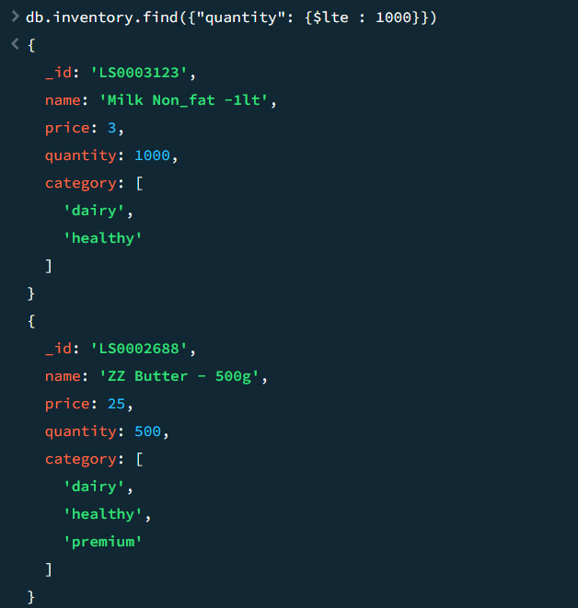

- $ne operator
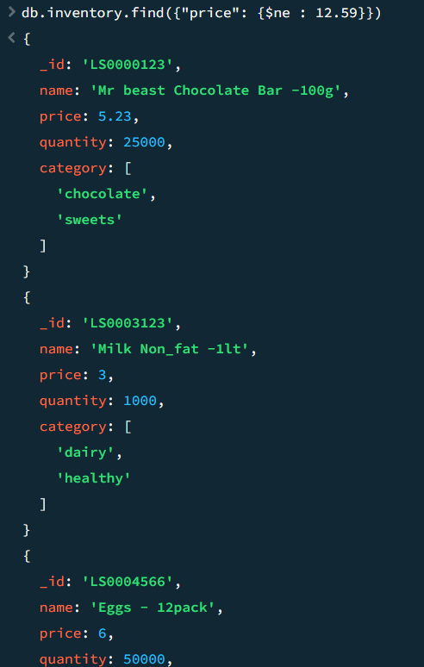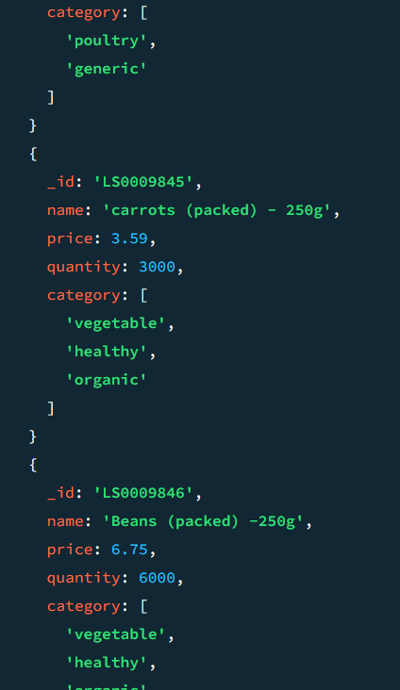

Practical 6 : Performing MongoDB Logical Operators
Data :
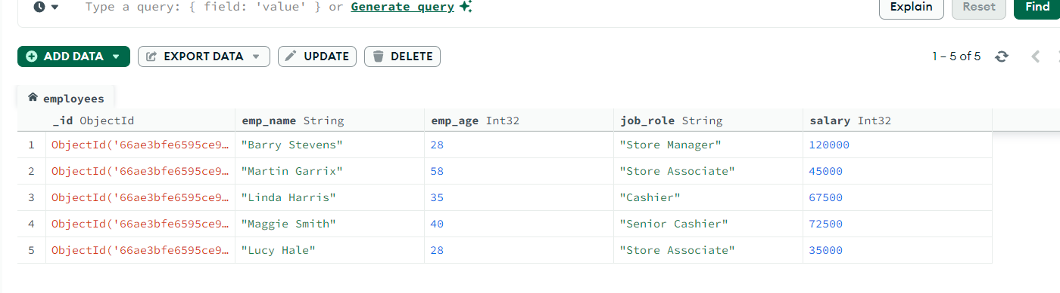
1. Find Employees whose job role is Store Associate and age is greater than 20 but less
than 30.
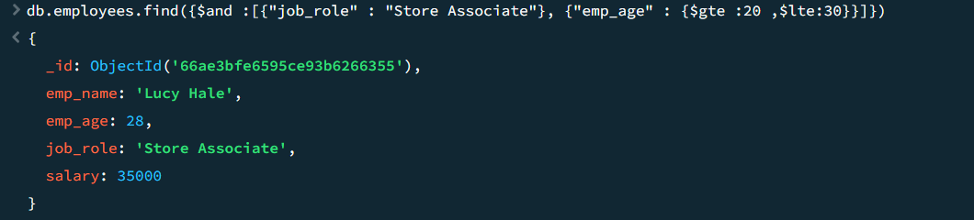
2. Find Employees whose job role as Senior Cashier or Store Manager
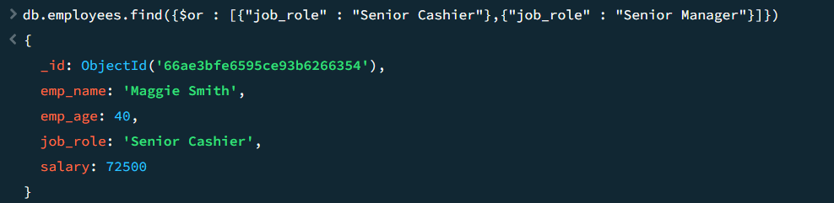
3. Using $nor Operator
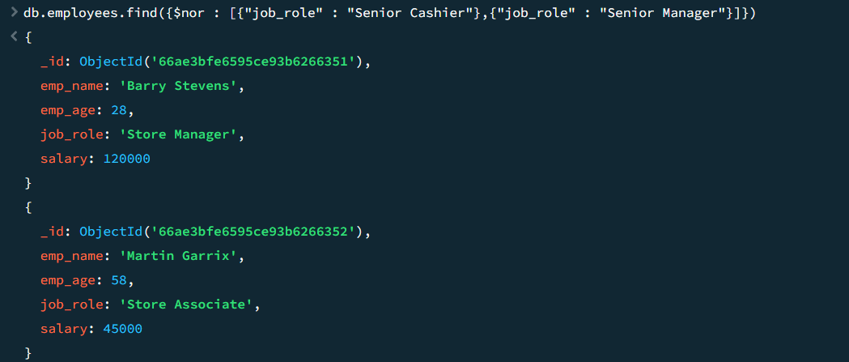

4. Using $not operator
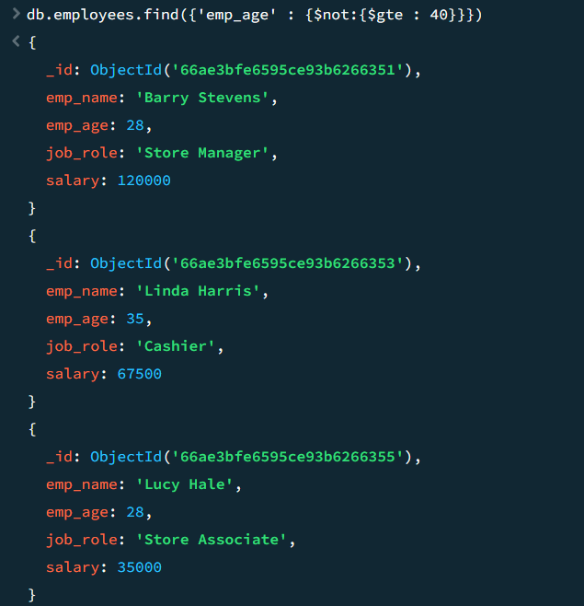

Practical 7 : Performing MongoDB $abs , $floor and $ceil operations
Data :
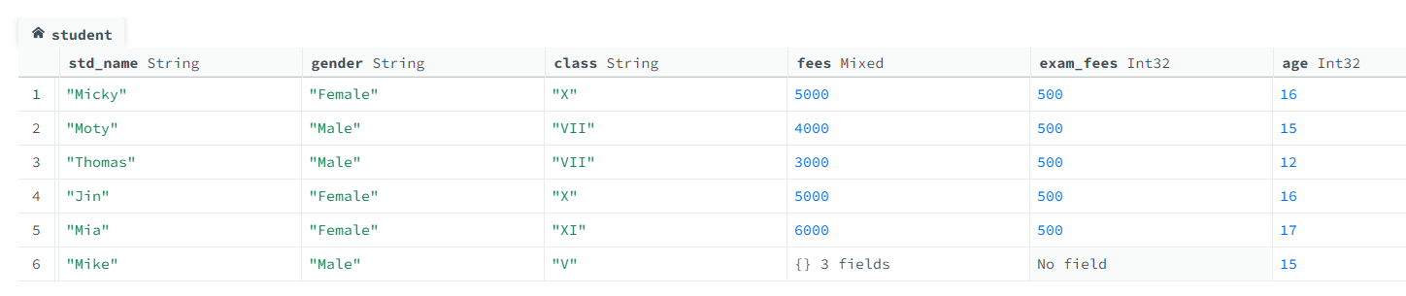
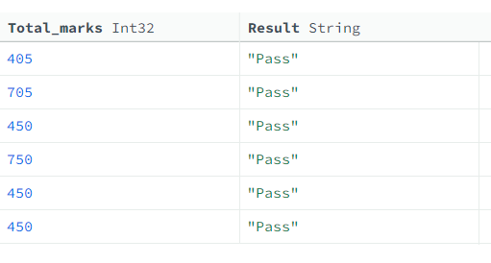

$abs :

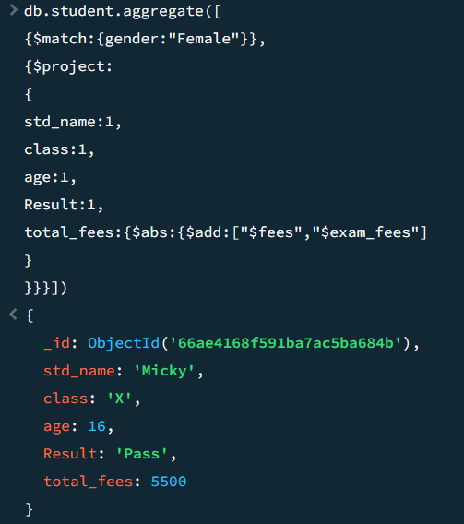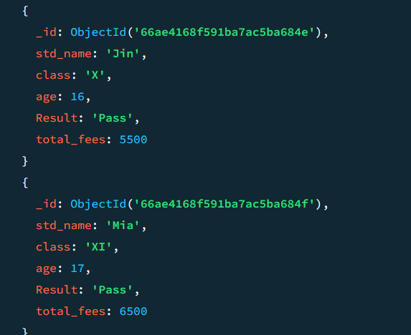

$floor
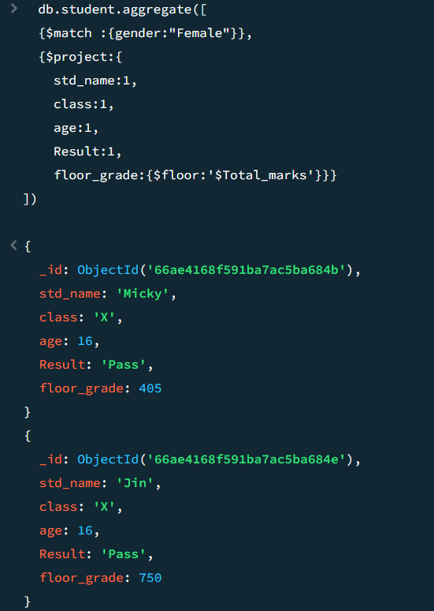
$ceil
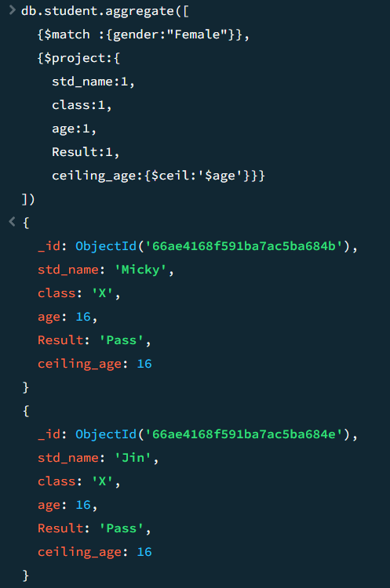

Practical 8 : Performing MongoDB $log , $mod , $divide and $multiply operations
Data :
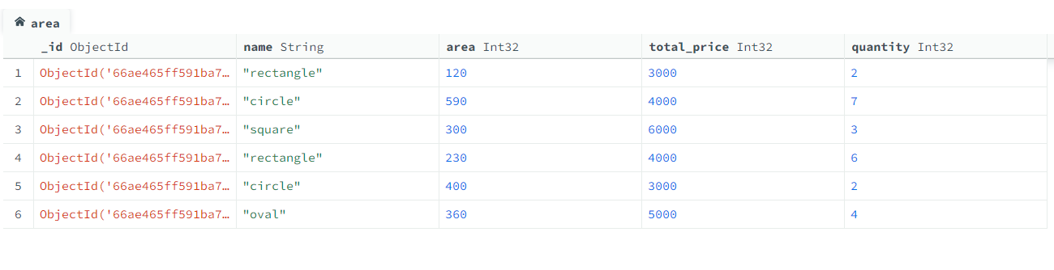
$log
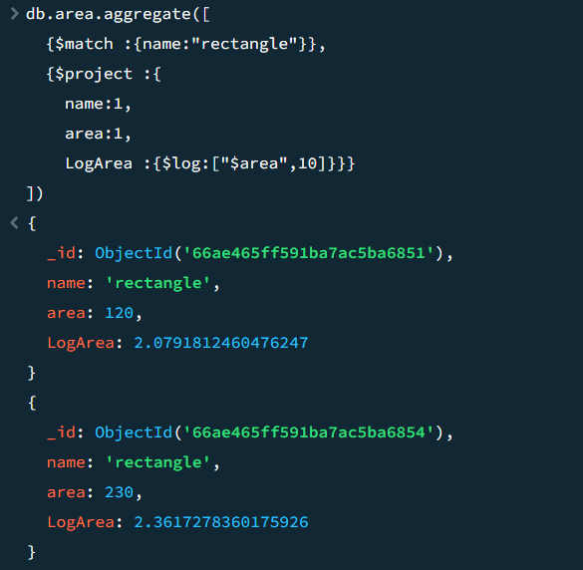

$mod
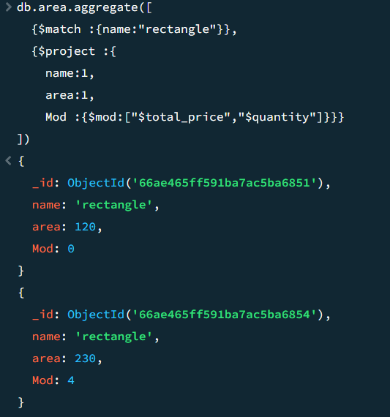
$divide
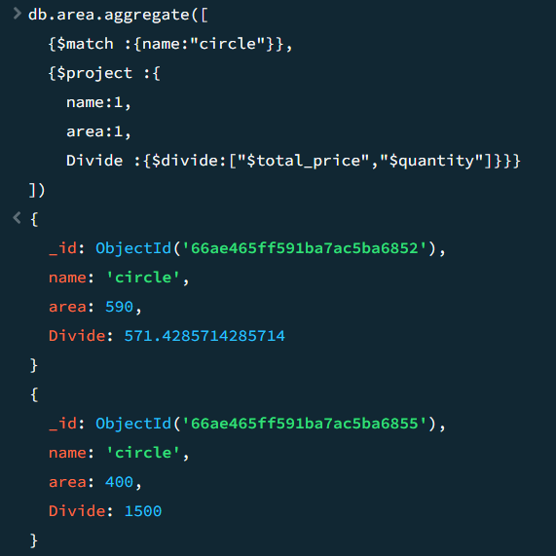
$multiply
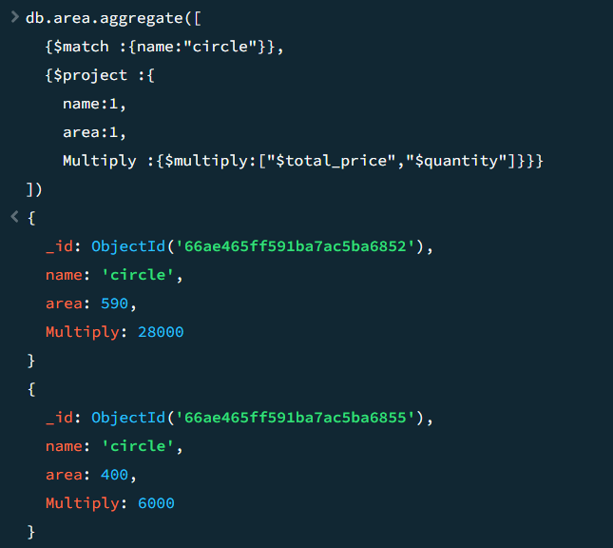

Practical 9 : Performing MongoDB $pow , $sqrt , $subtract operations

$pow
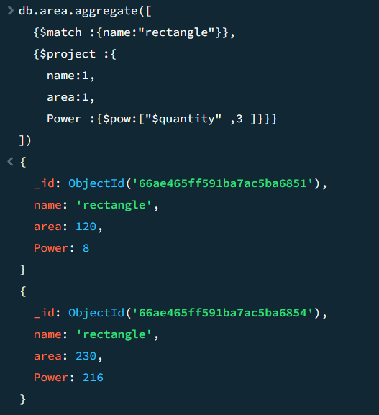
$sqrt
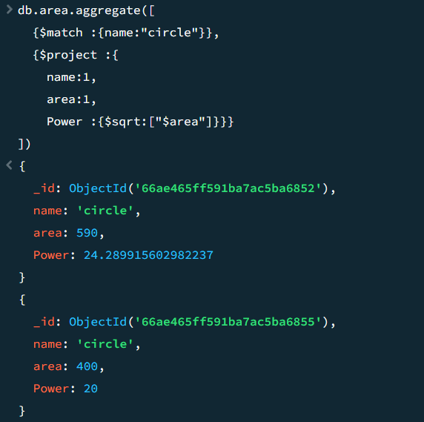

$subtract
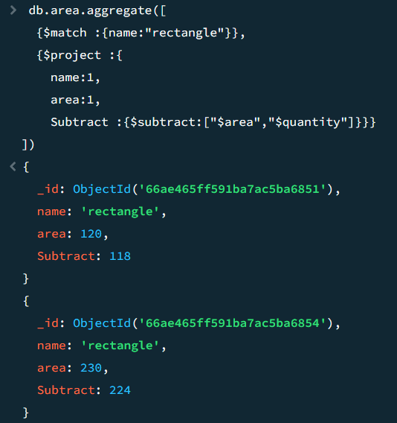

Practical 10 : Performing MongoDB $trunc, $round , $compare operations
Data :
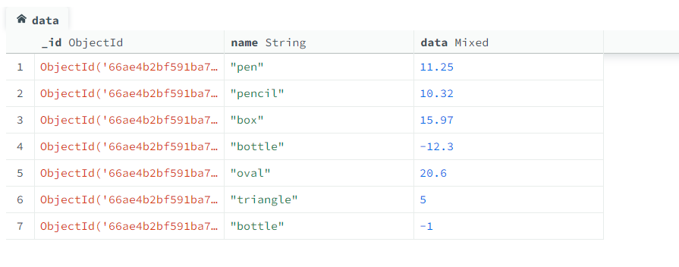
$trunc
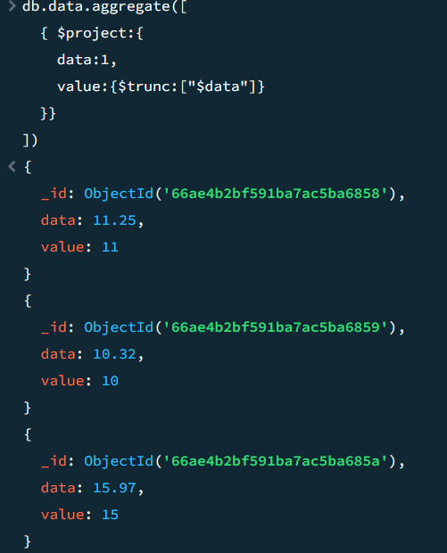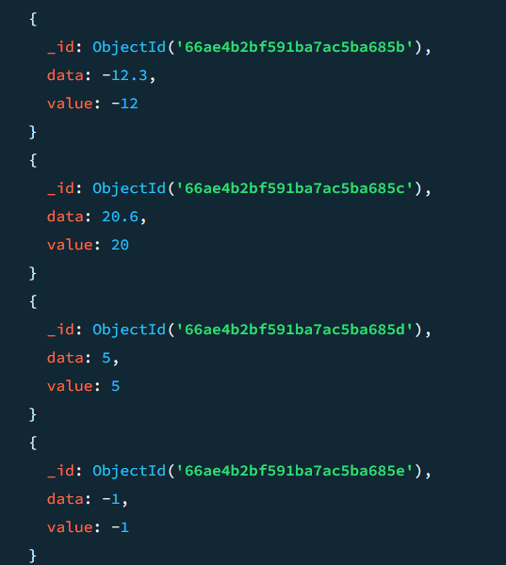
$round
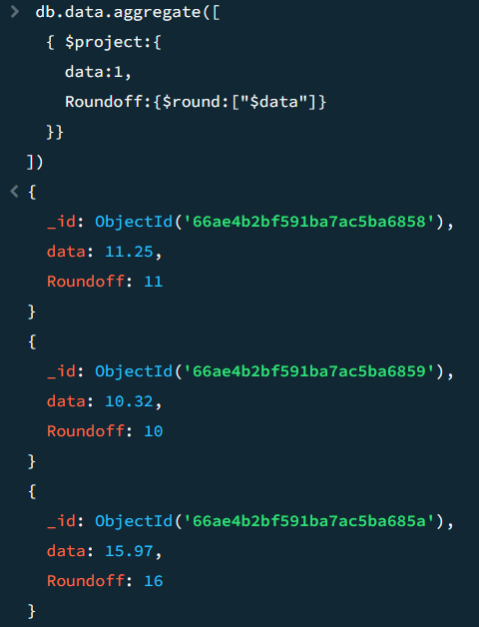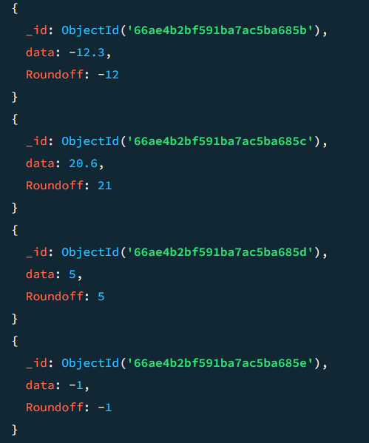

$compare
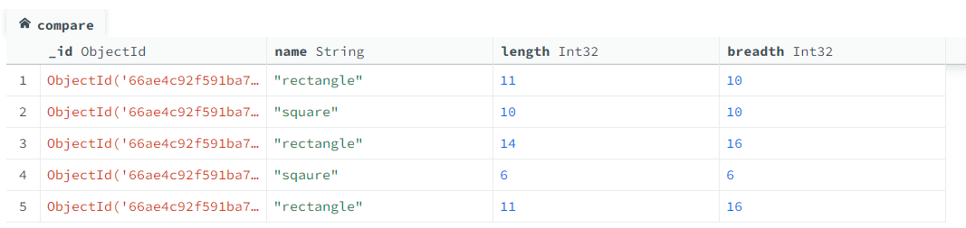
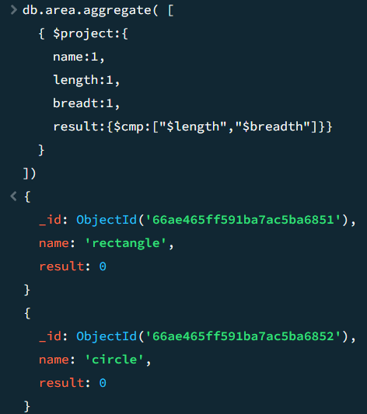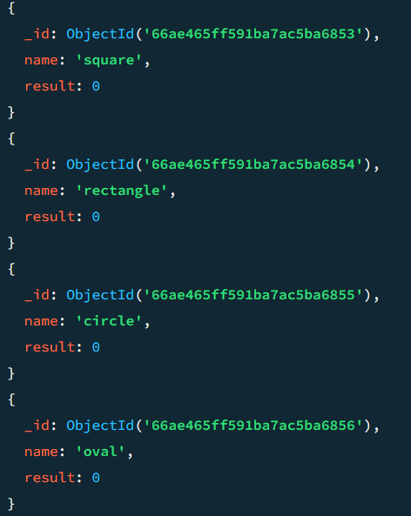
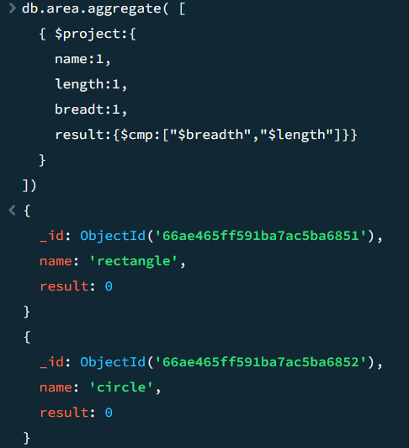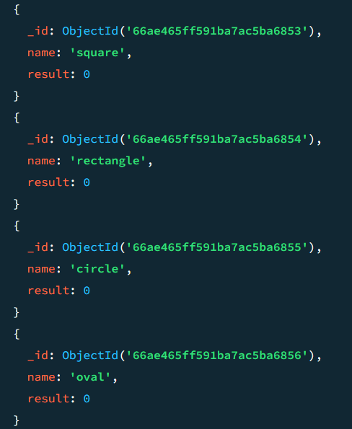

Practical 11 : Performing MongoDB $concat, $size , $rename operations
Data :
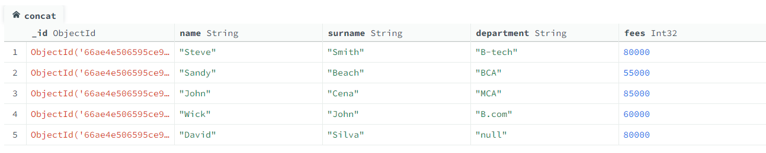
$concat
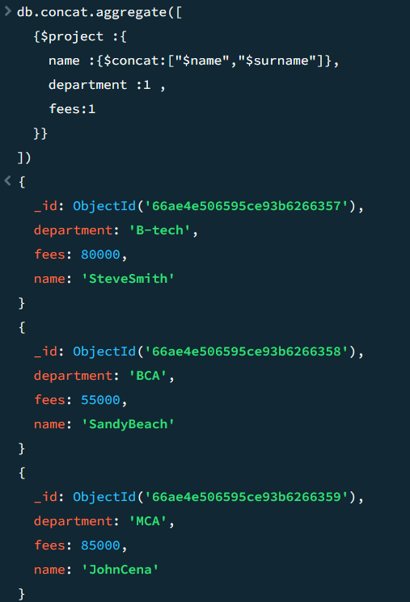
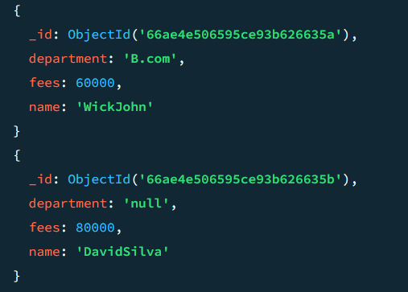

$size
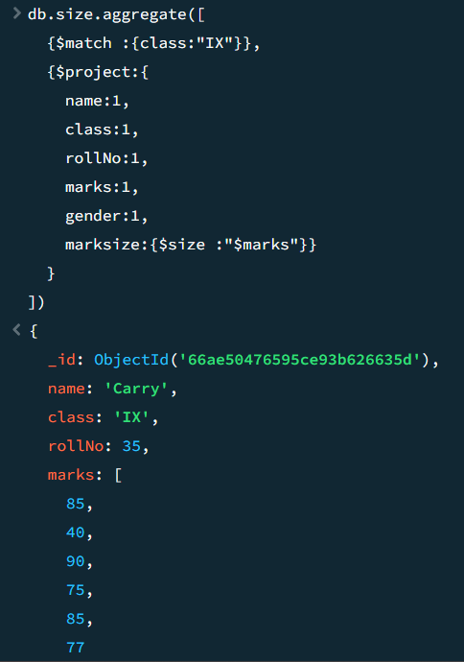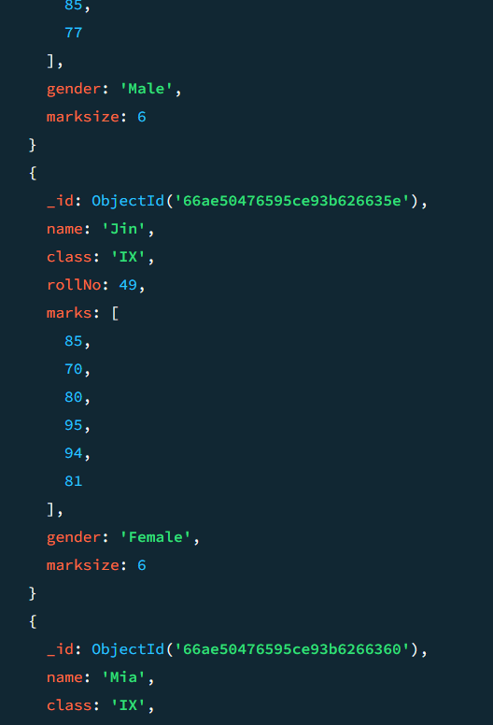

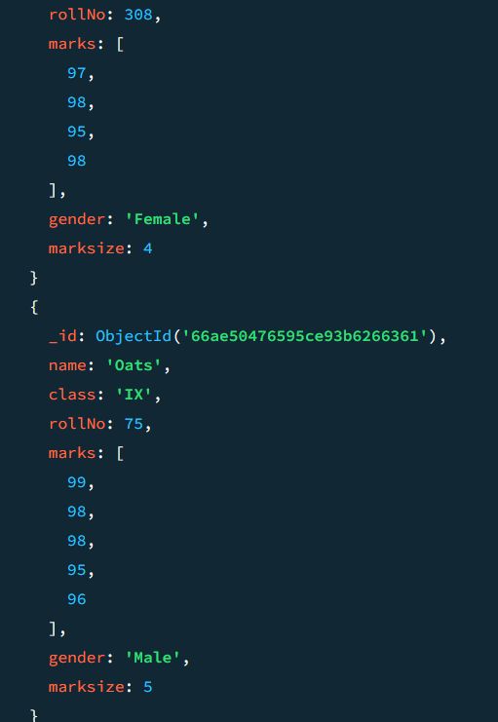

$rename
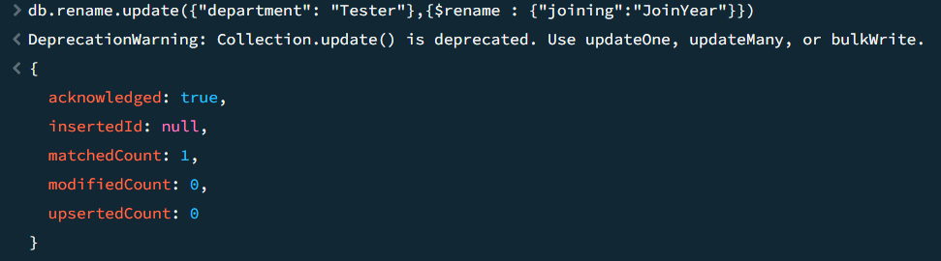
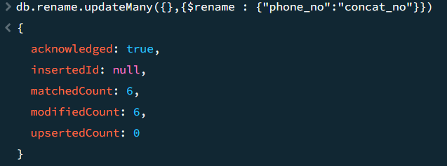

WEKA

Kappa Statistics :
- It is going to measure the precision of the data items.
- It determines the chance agreement by guessing a possibility, in the same way, the chance of correct answers is possible by multiple tests

Absolute Error :
- Amount of error calculate

Mean Absolute error :
- It is the Average of all absolute errors.

Root Mean Squared Error :
- It measures the difference between the values which are predicted by the model and the actual value

Relative Absolute Error :
- The absolute error gives how large the error is, while the relative error gives how large the error is related to the correct value.

Root Relative Squared Error :
- It is relative to what it would have been if a simple predictor had been used
- True Positive , False Positive

Precision:
Almost near to accuracy

Practical 12 : Implementation of Supervised Learning

12 A ) Decision Tree
Dataset : weather.numeric
Step 1 : Loading the dataset
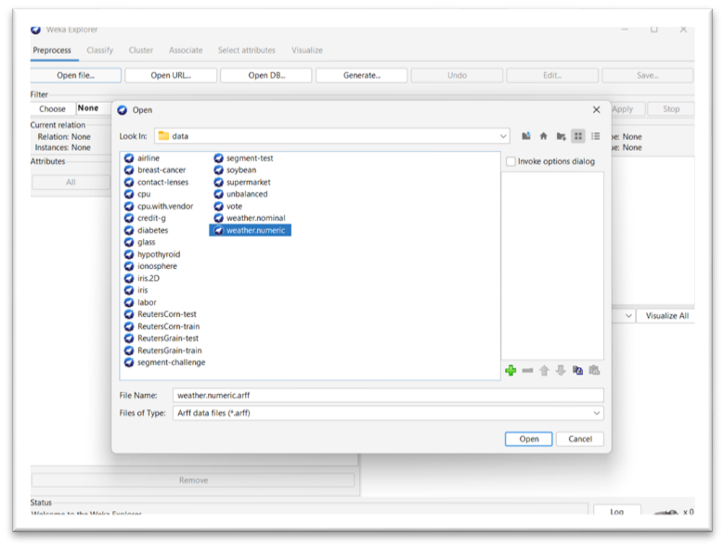

Step 2 : Go to classify choose tree > J48 and click on start
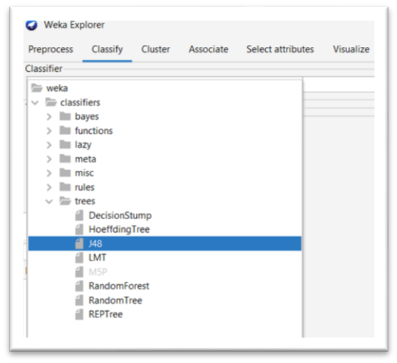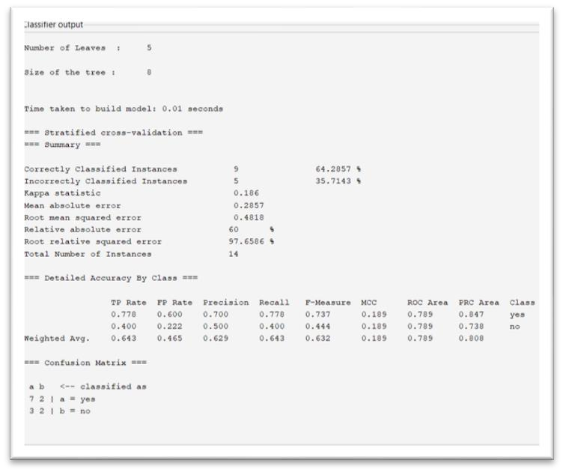

Step 3 : Now we can Visualize the model
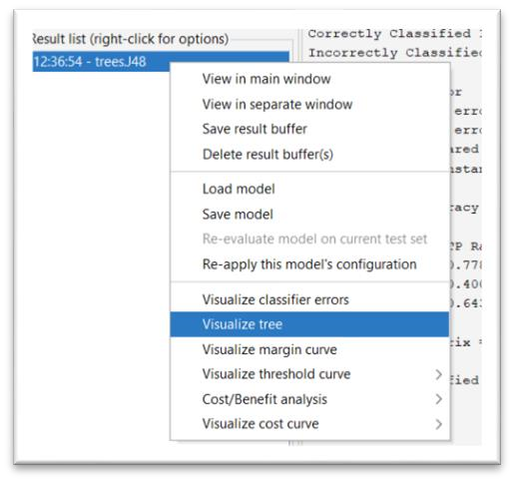
Visualizations :
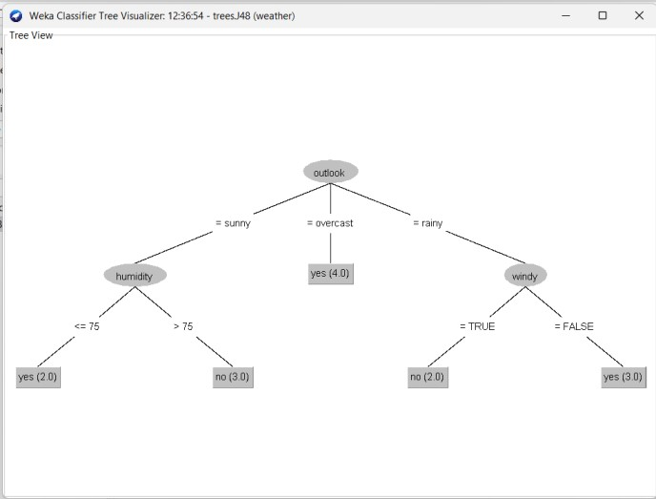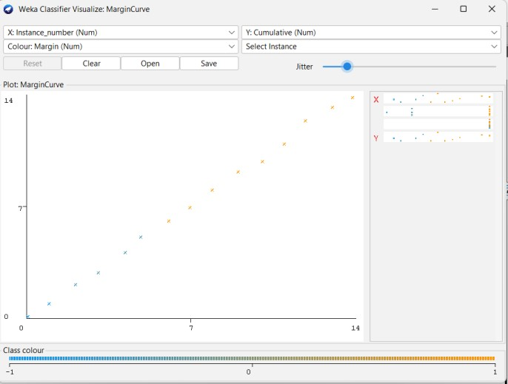

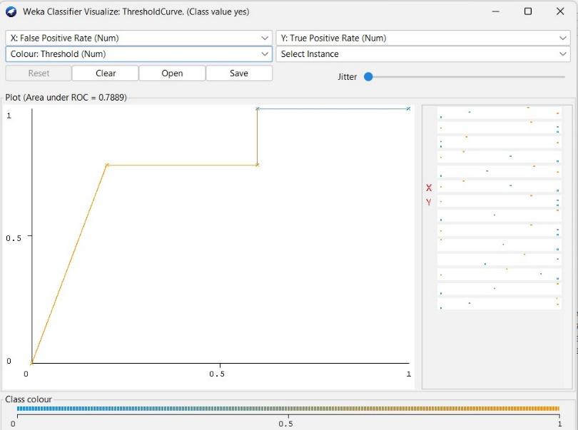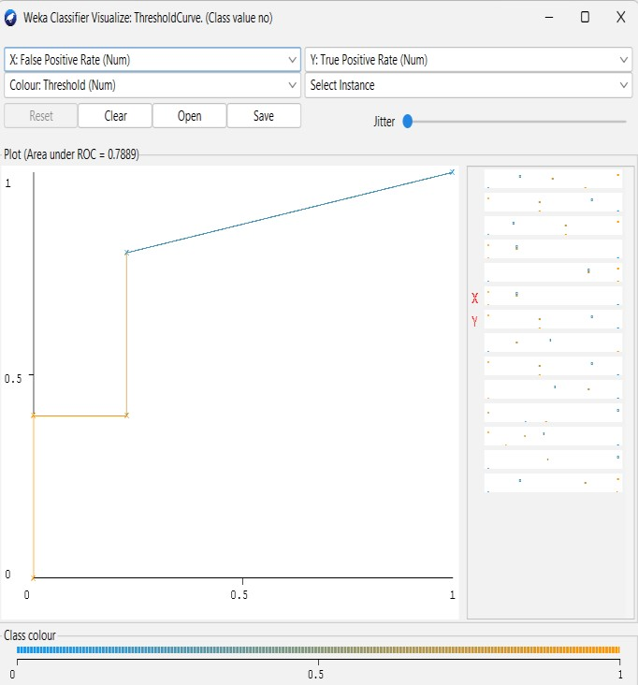

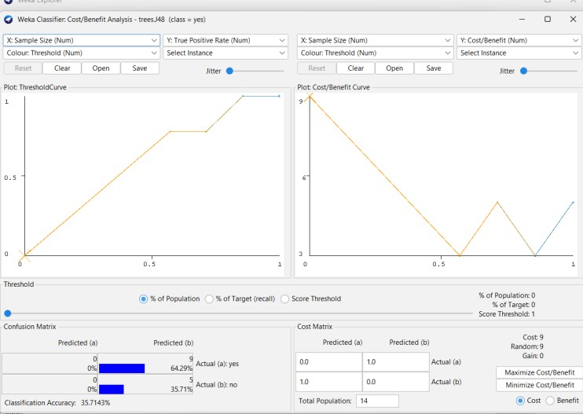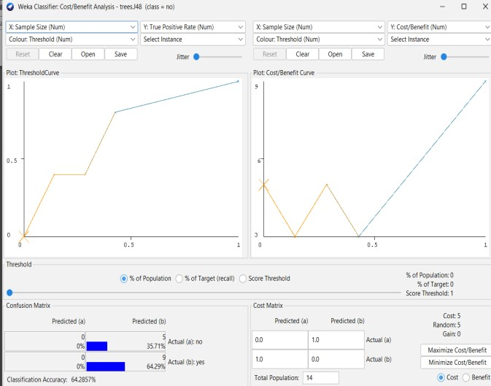

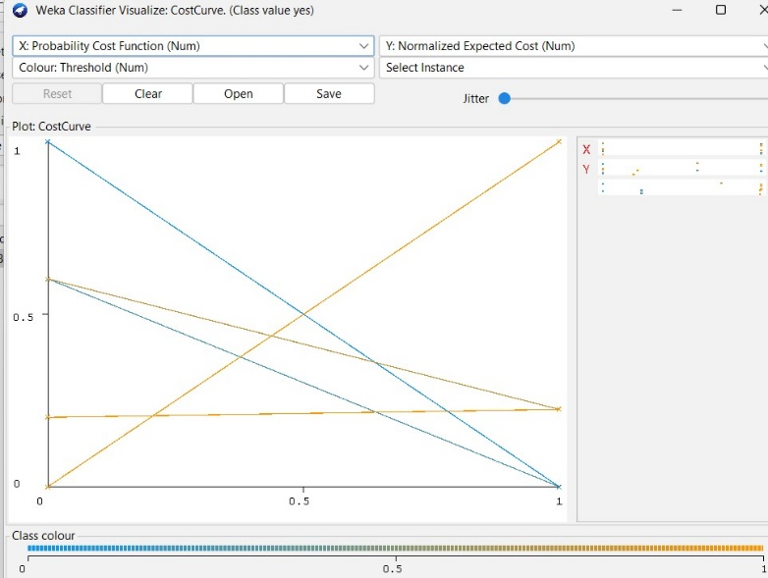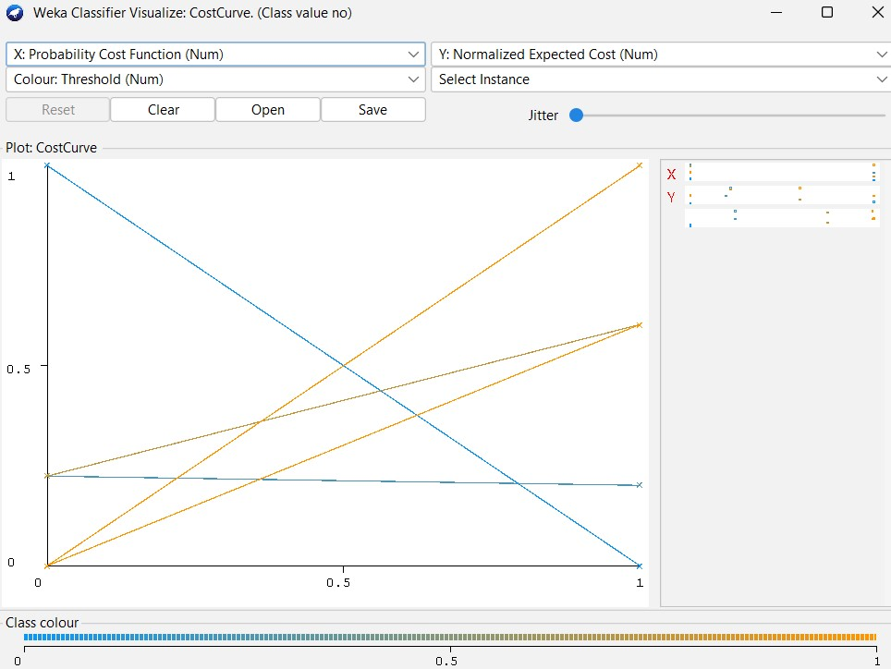

12 B) Logistic Regression
Dataset : ionosphere
Classify > functions > Logistic
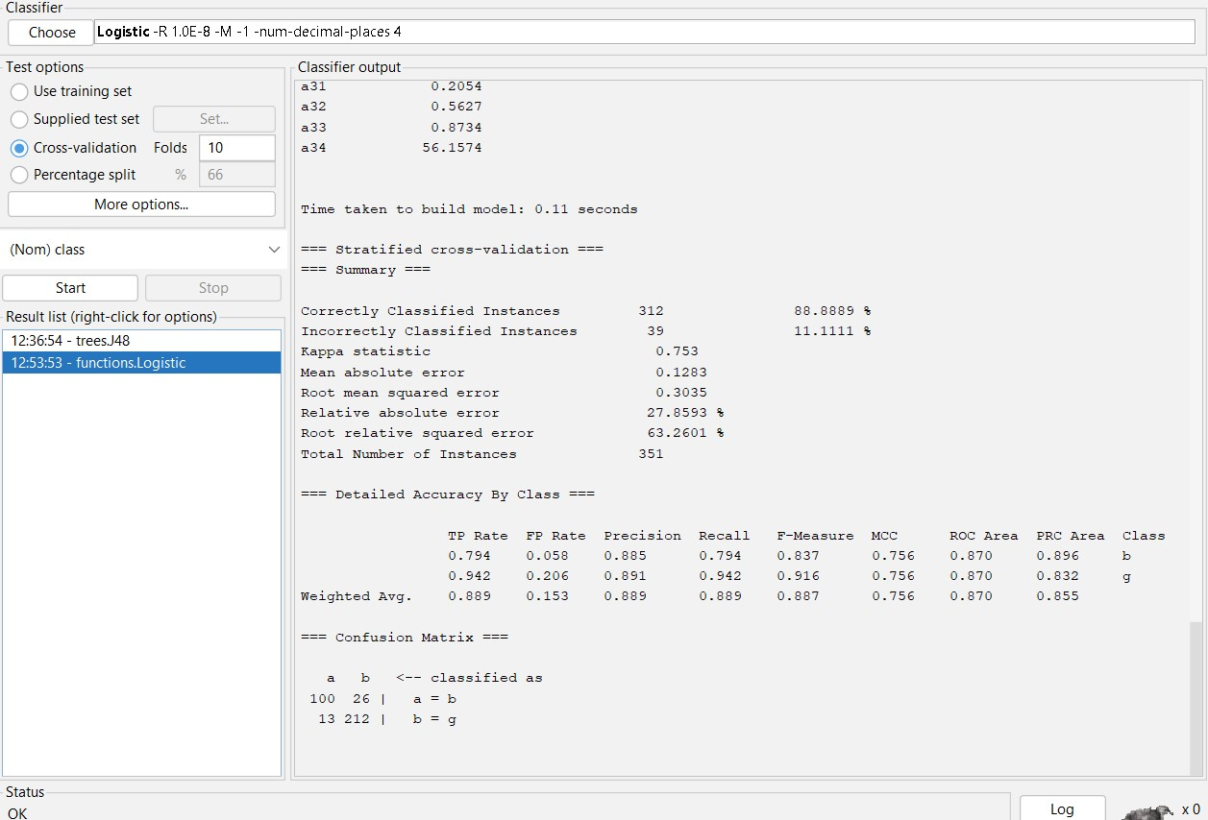
Visualization :
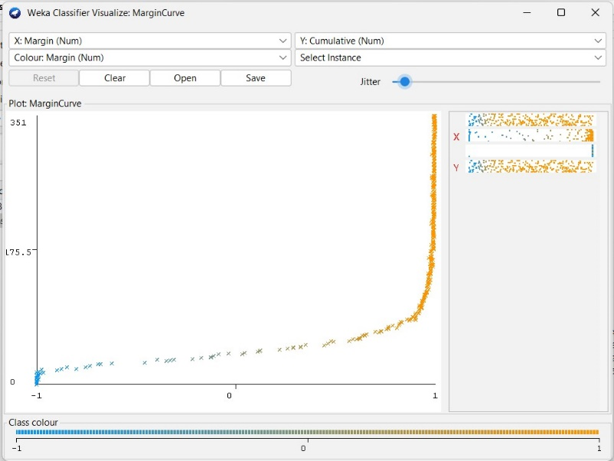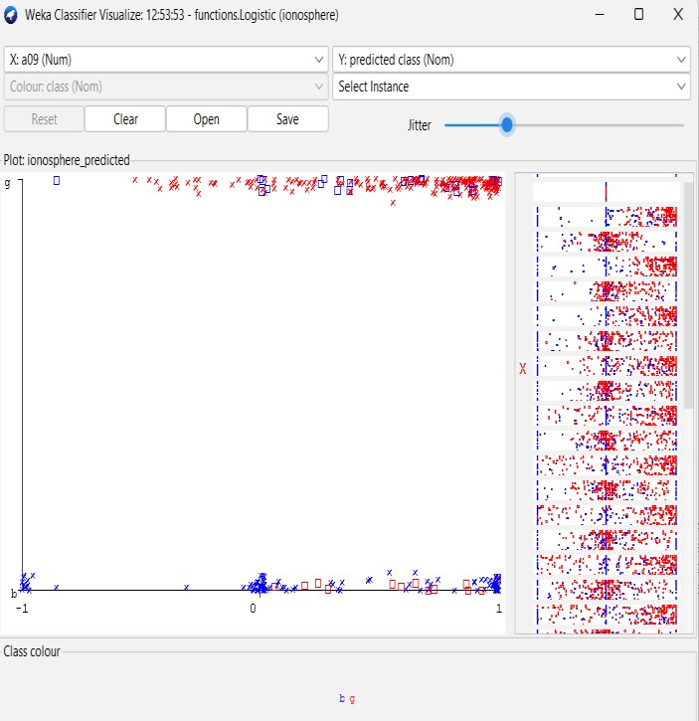

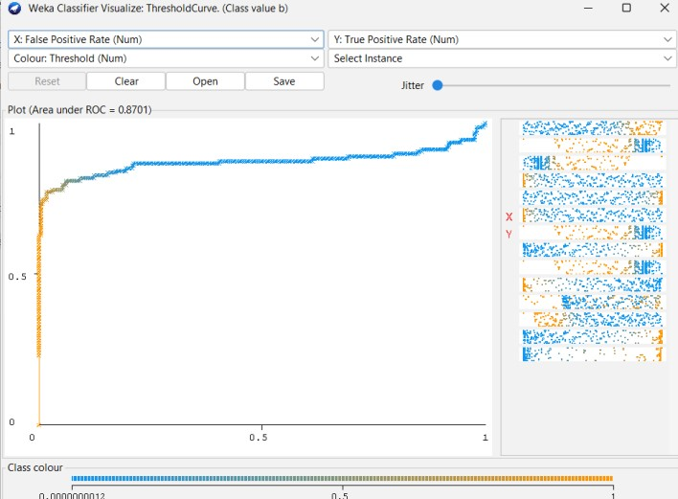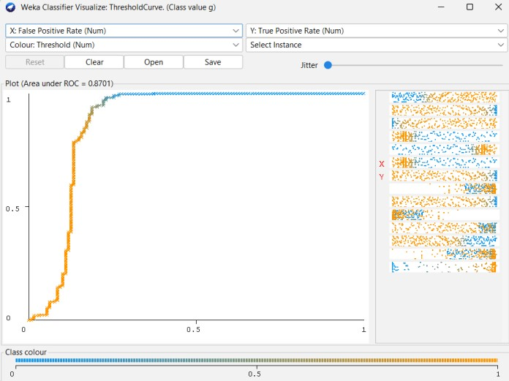

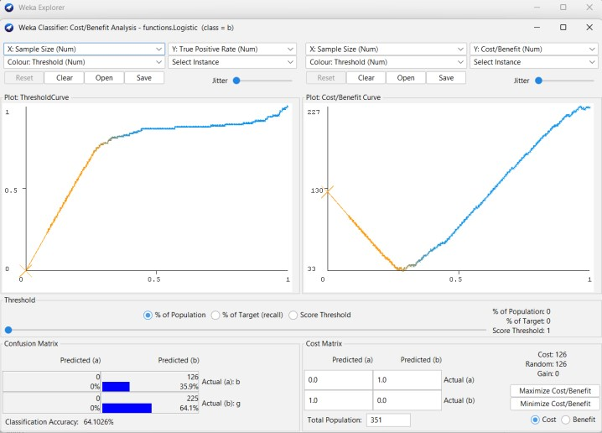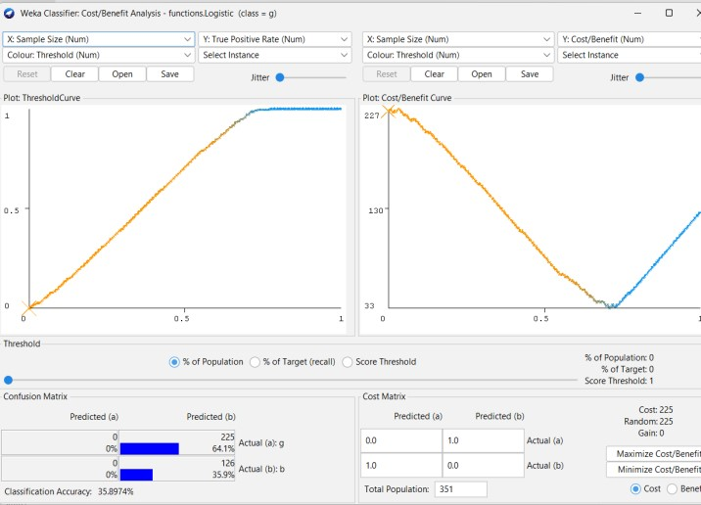

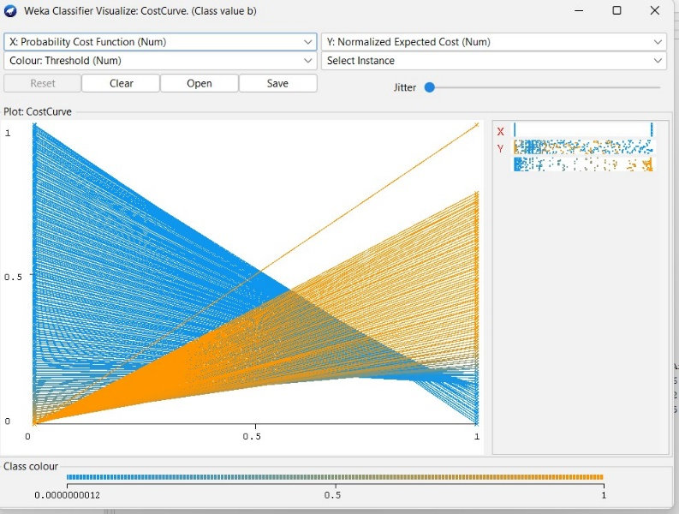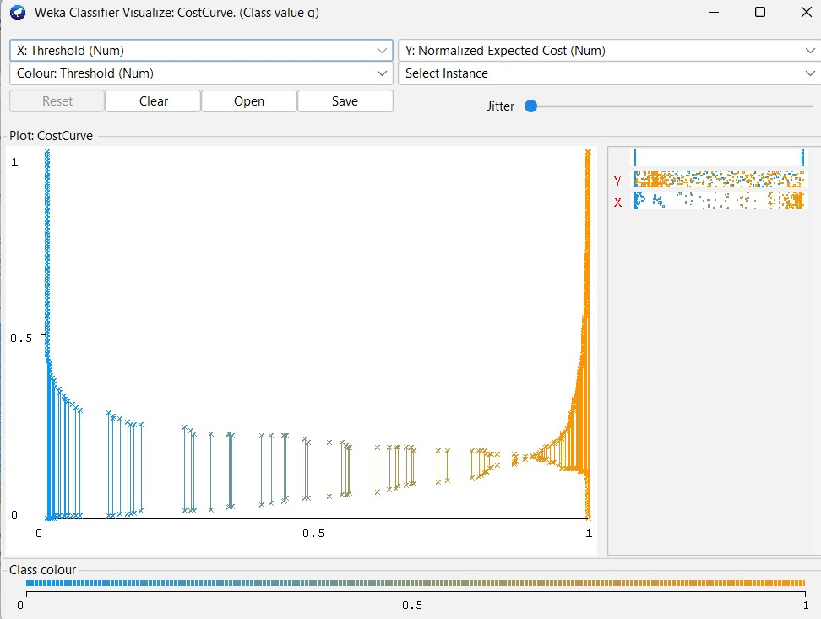

12 C) KNN
Dataset : ionosphere
Classify > functions > SMO
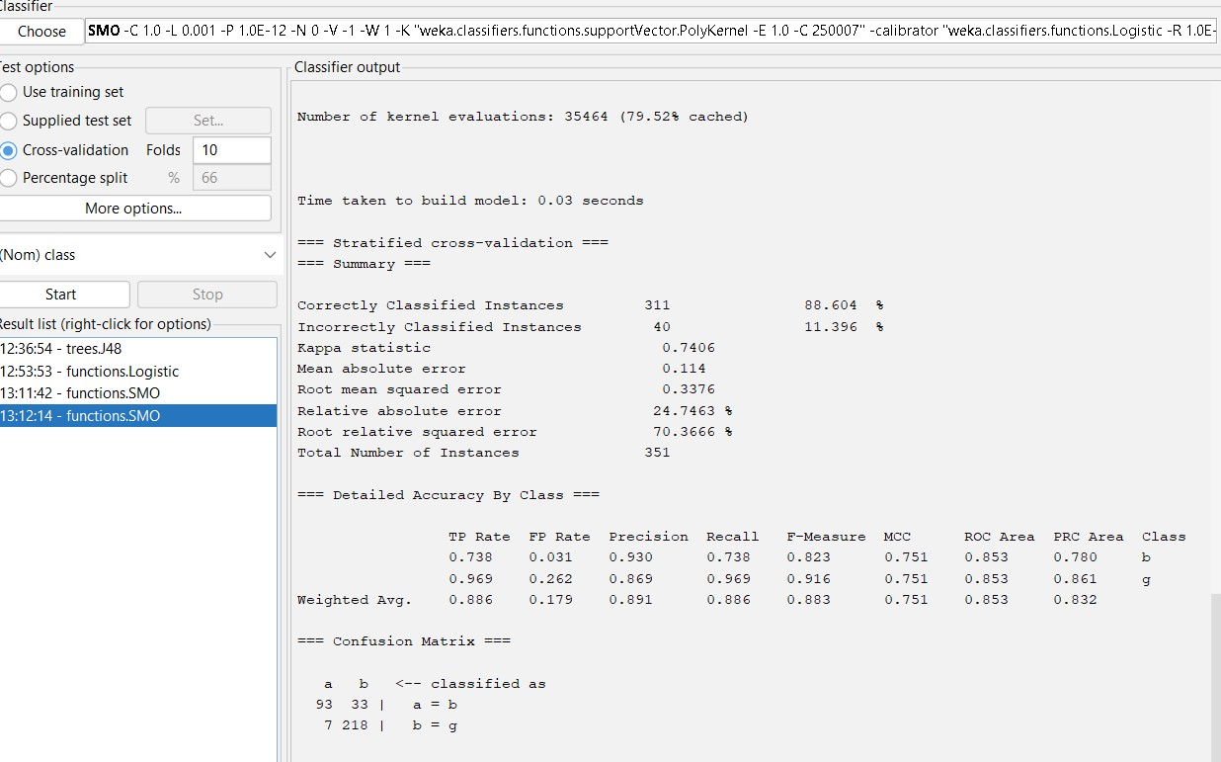

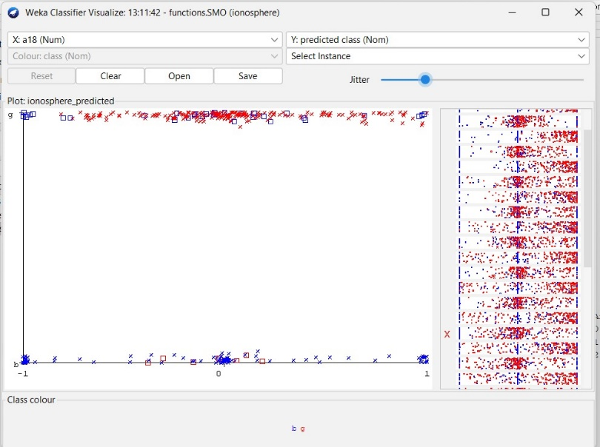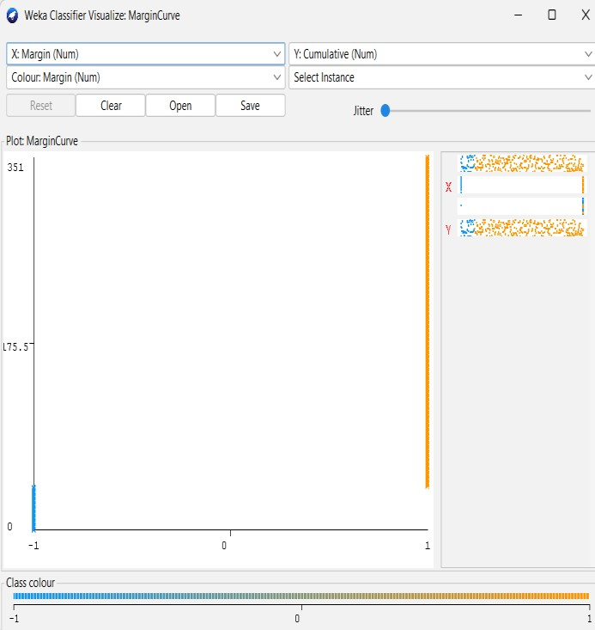

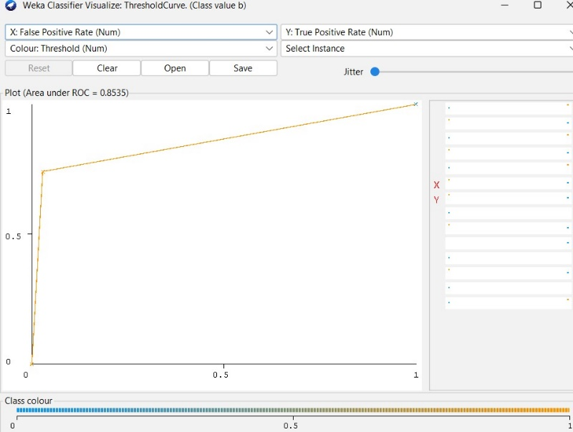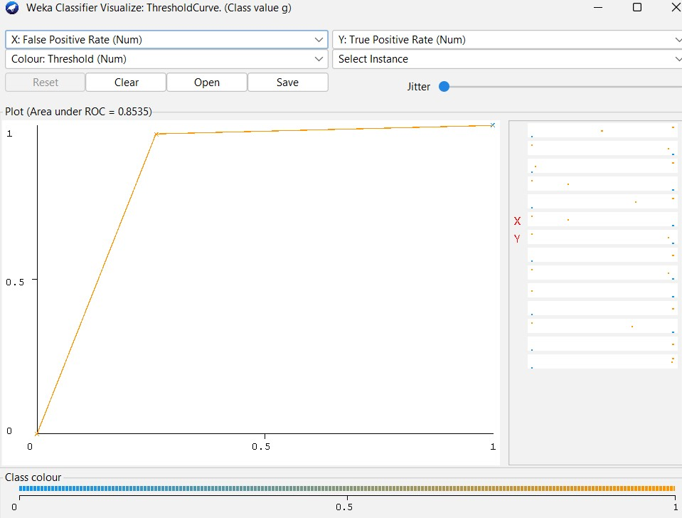

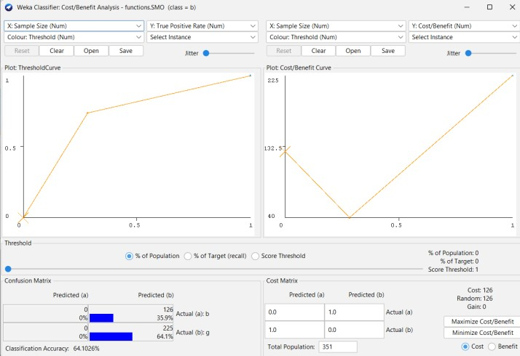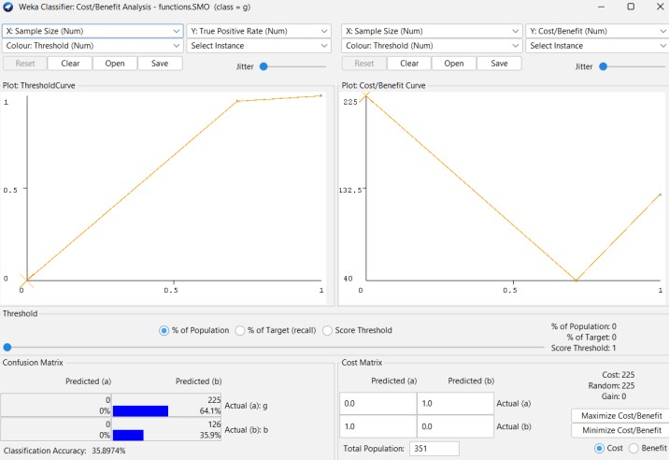

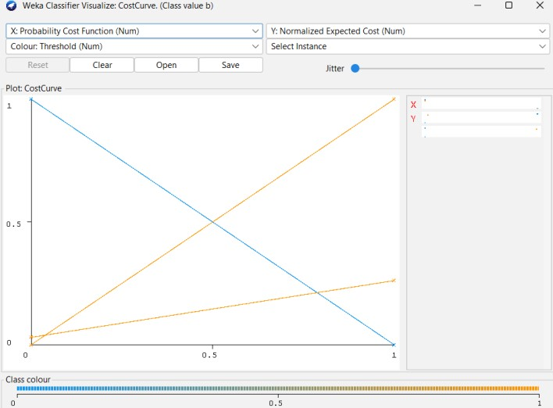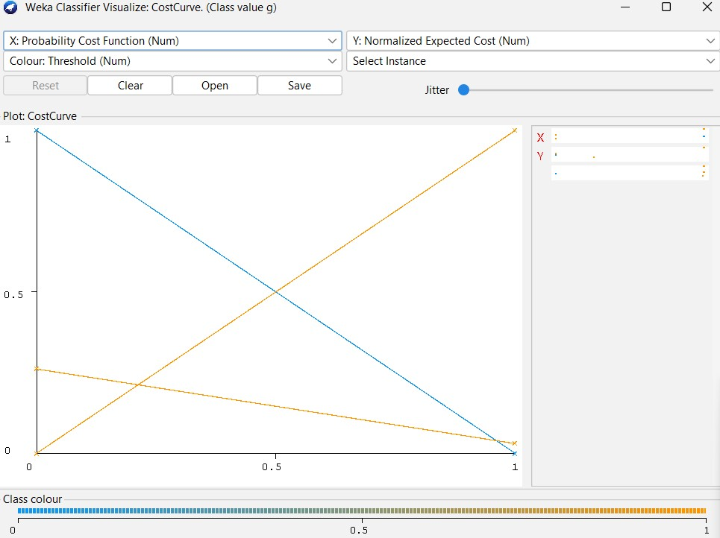

12 D) Linear Search - Euclidean Distance
Dataset : ionosphere
Classify > Choose > lazy > IBk
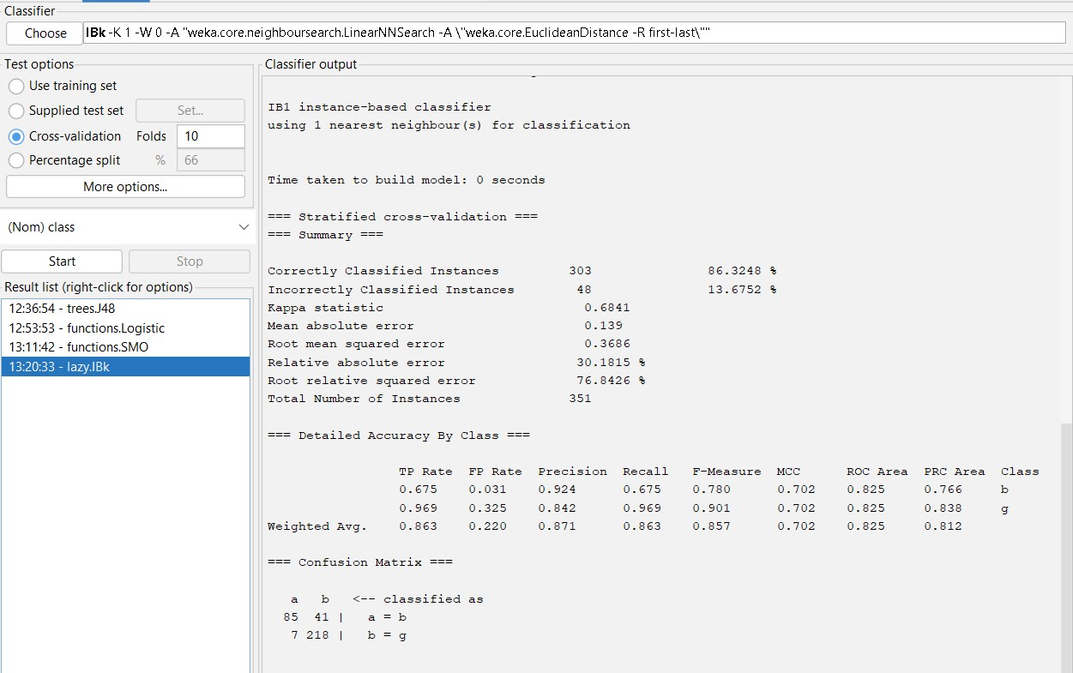

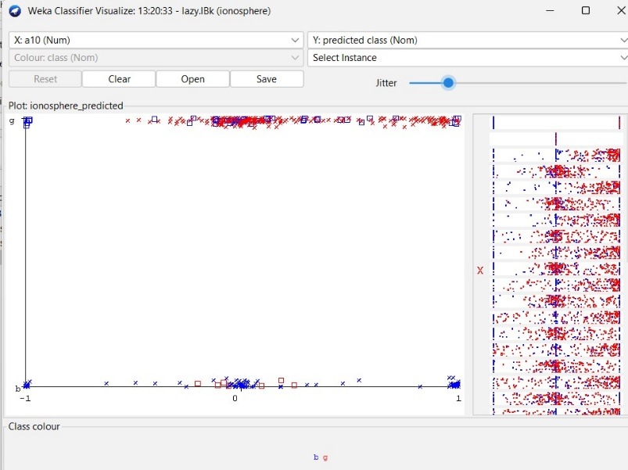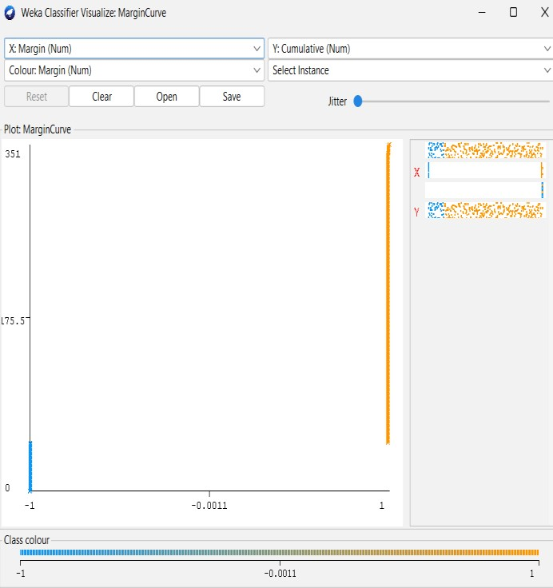

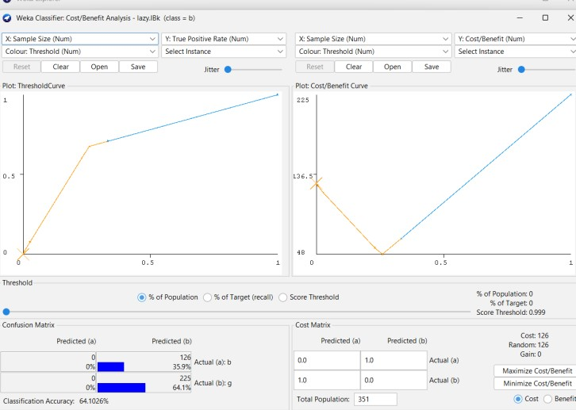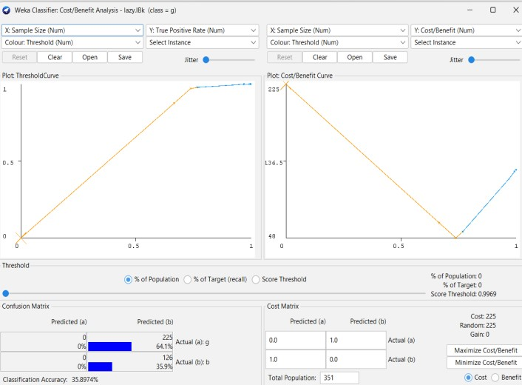

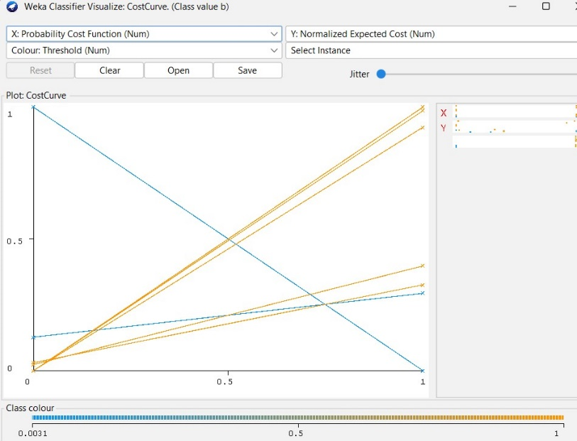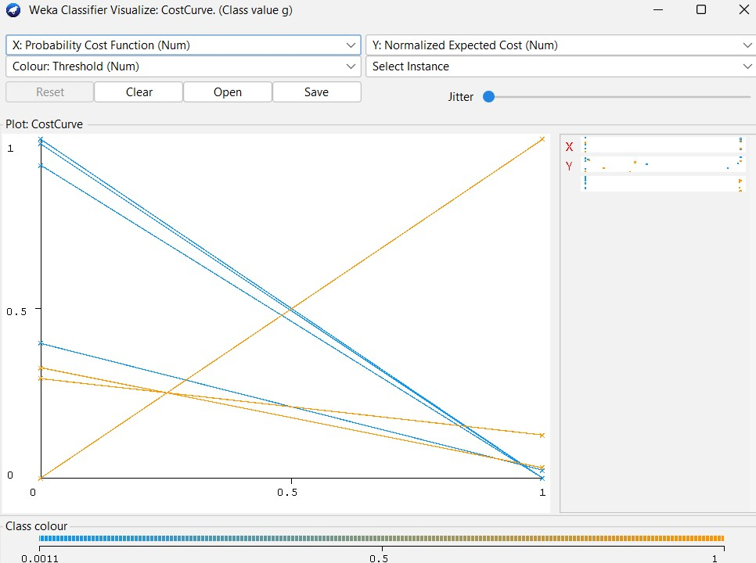

12 E) NaiveBayes Classifier
Classify > Choose > bayes > NaiveBayes

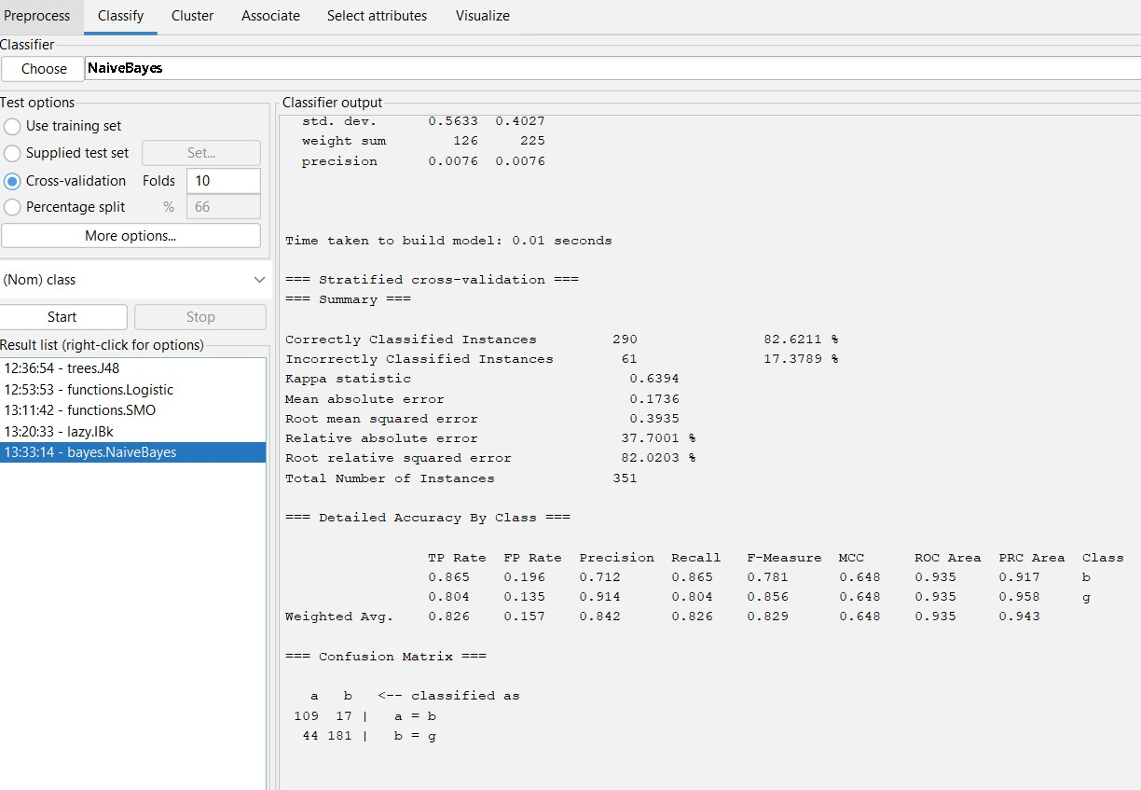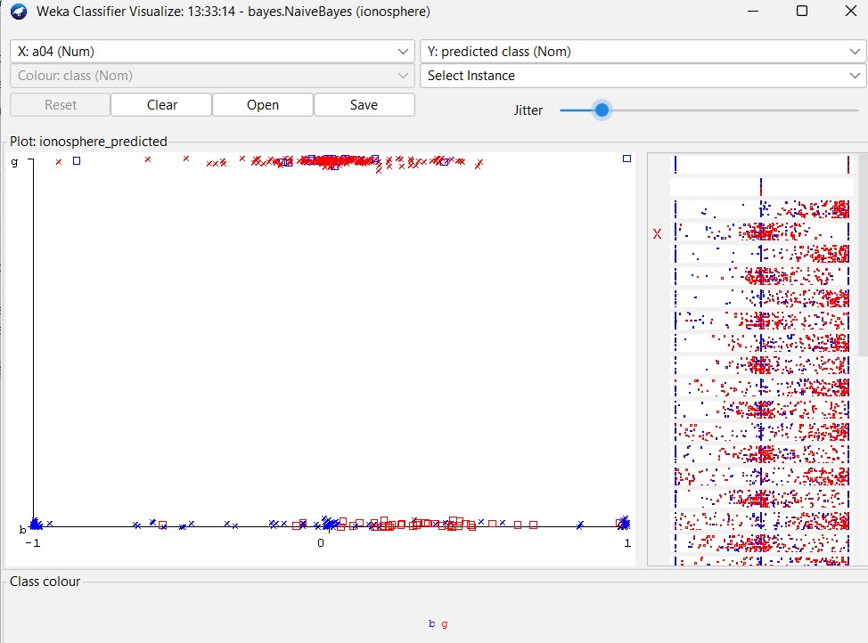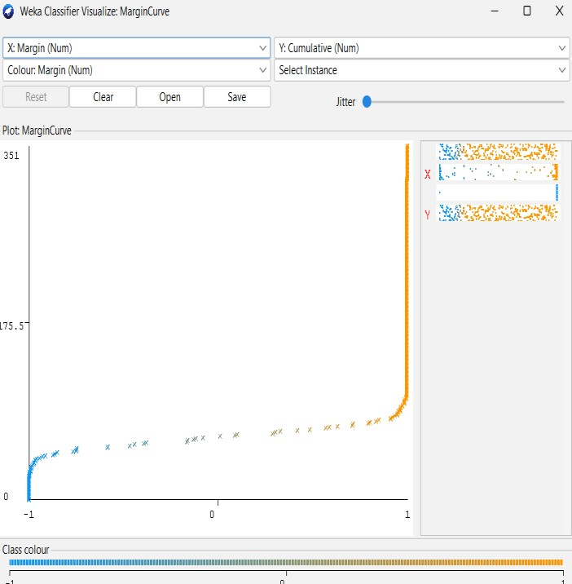

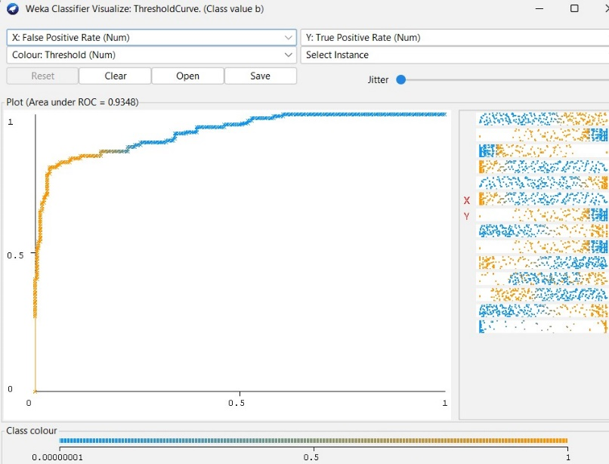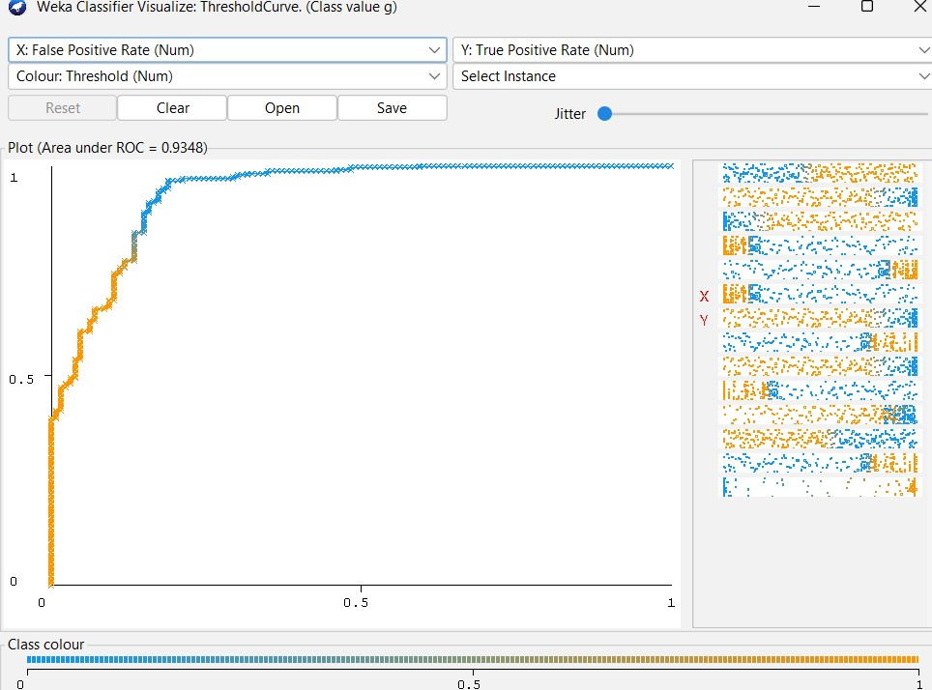

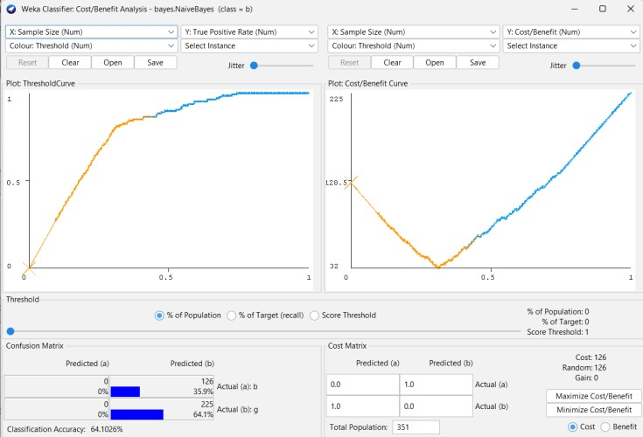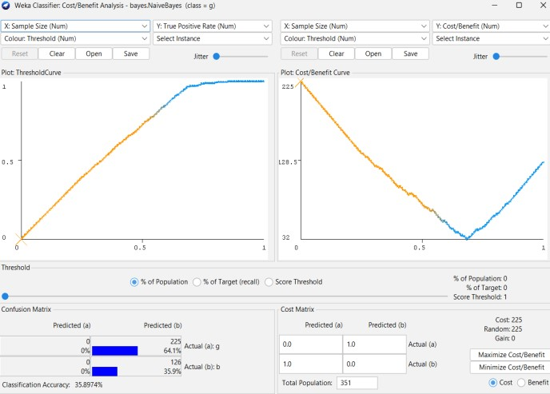

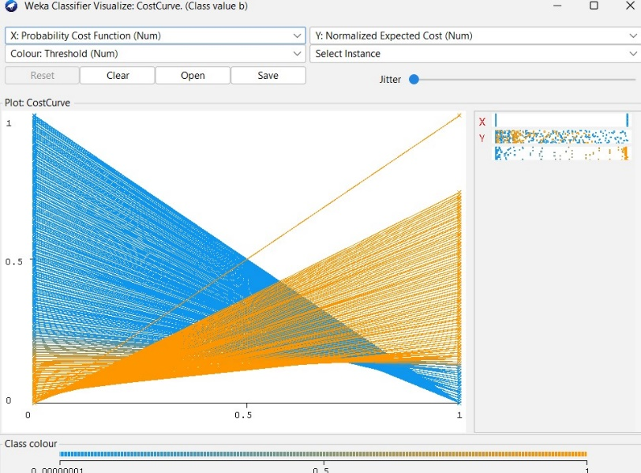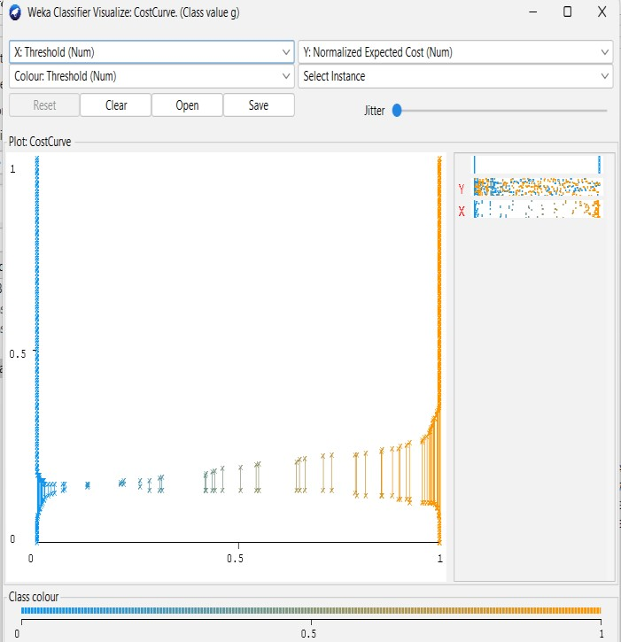

Practical 13 : Implementation of Unsupervised Learning

13 A) Clustering
Dataset : iris
Cluster > Choose > EM >start
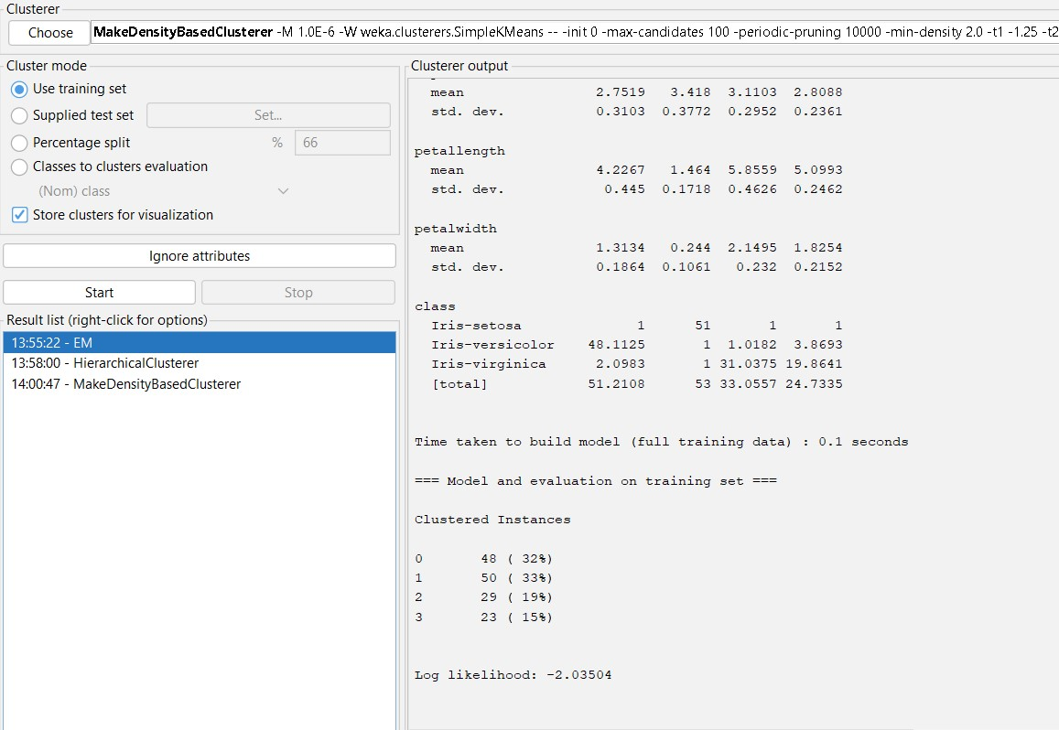

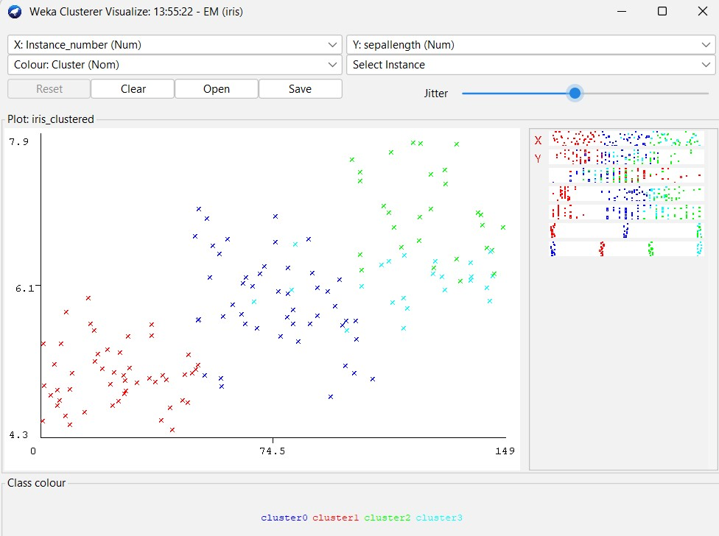

Hierarchical Clustering
Dataset : iris
Cluster > Choose > HirerachicalClusterer >start

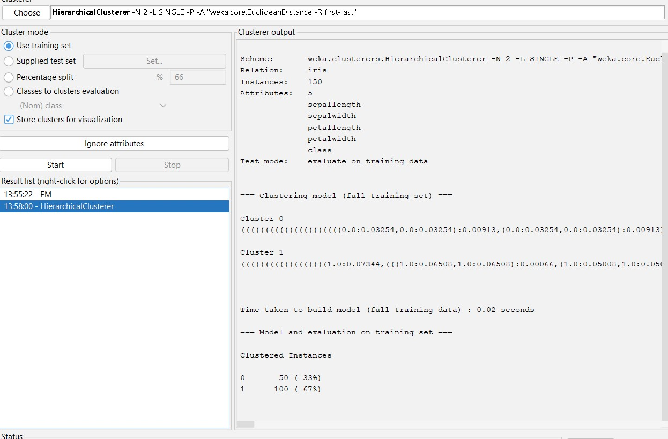

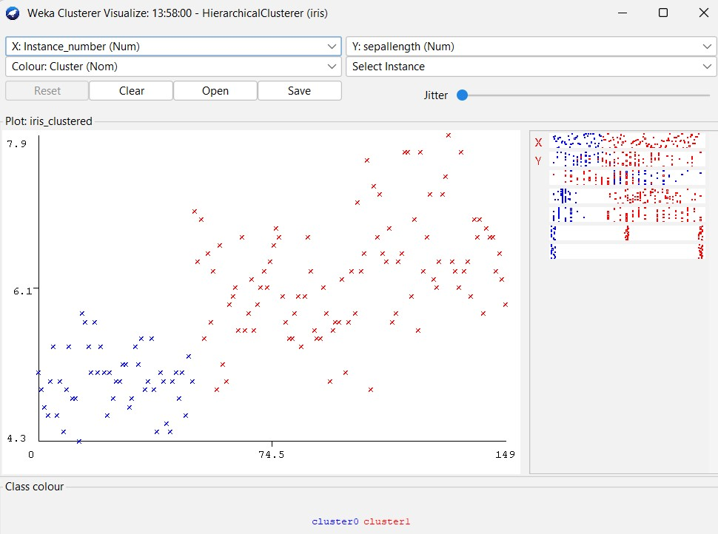

Density Based Cluster
Dataset : iris
Cluster > Choose > MakeDensityBasedCluster >start
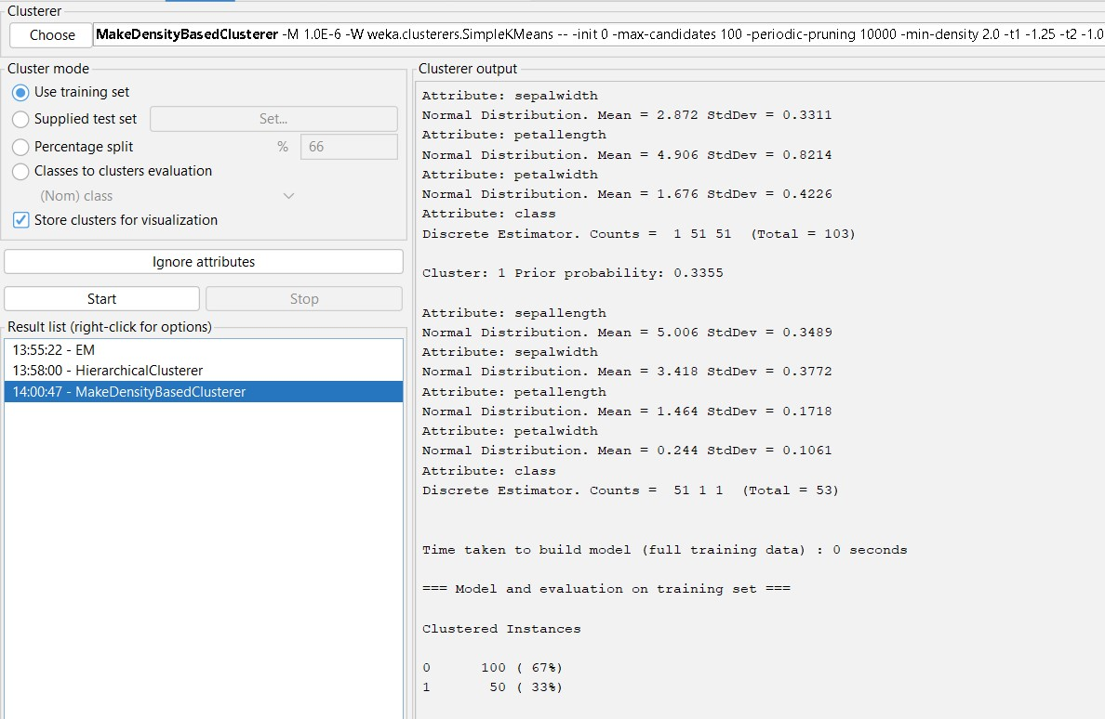

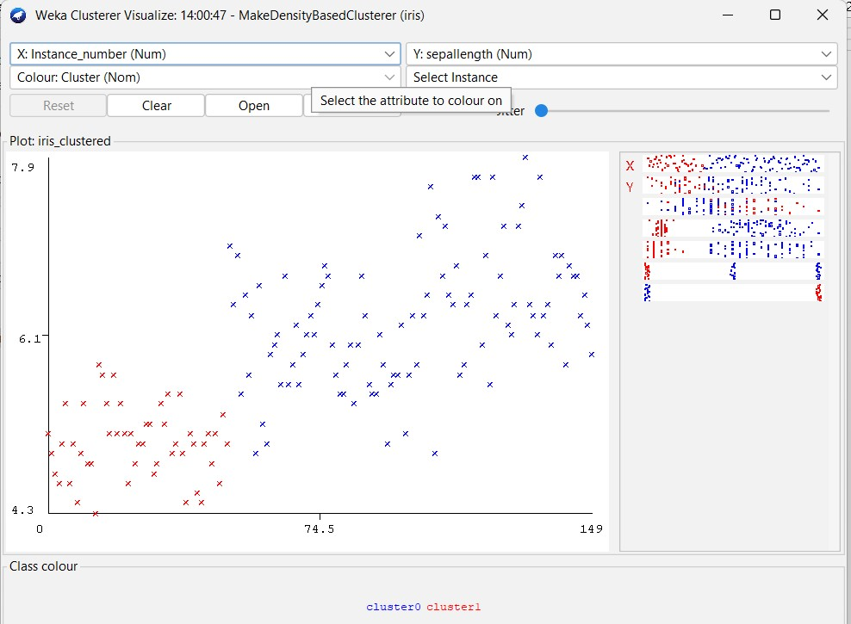

Simple KMeans :
Dataset : iris
Cluster > Choose > SimpleKMeans >start
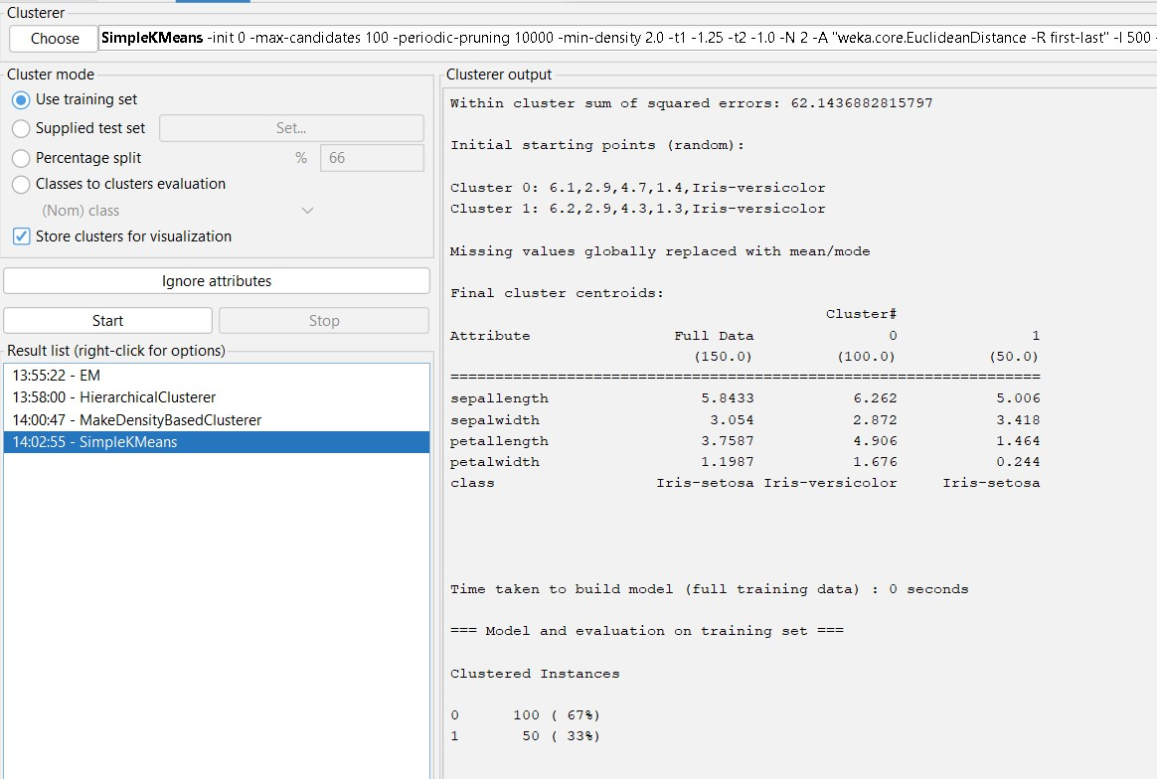

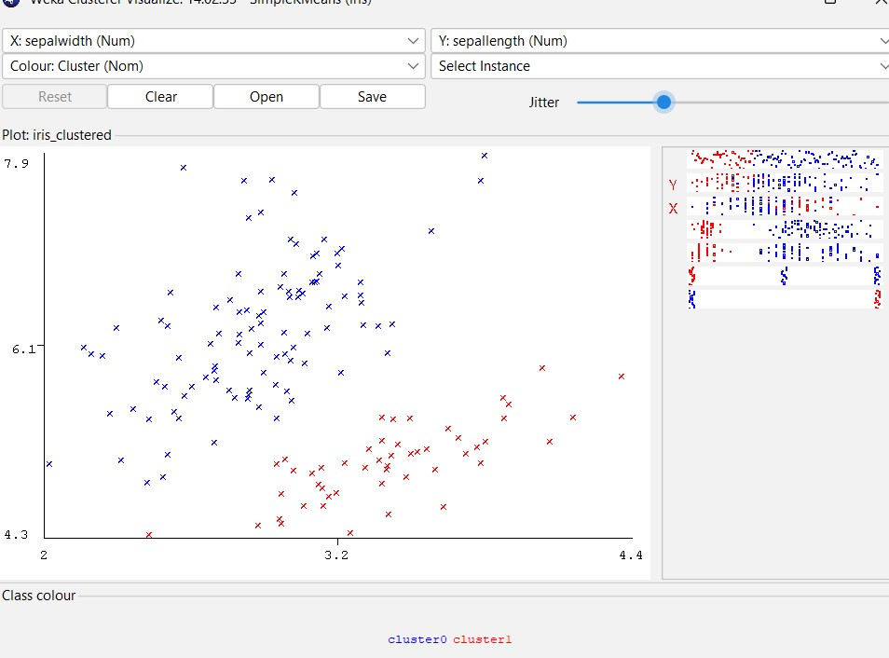

Apriori Algorithm
Dataset : Supermarket
Associate > Choose > Apriori > Start

